**Year 10**

**Physics**

**Name: \_\_\_\_\_\_\_\_\_\_\_\_\_\_\_\_\_\_\_\_\_\_\_\_\_\_\_\_\_\_\_\_\_\_**

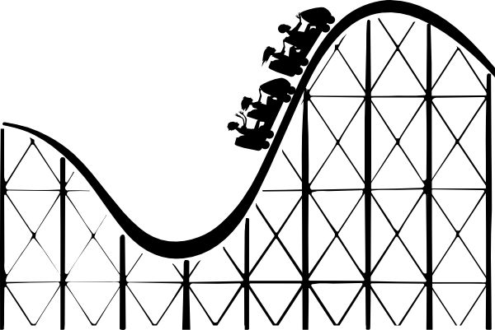

(2019)

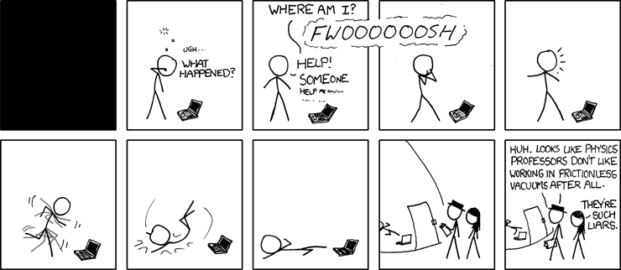

(Munroe, 2009)

**Weekly Review**

* Students are expected to complete and summarise coursework lesson by lesson.
* Understanding will be validated throughout the week to help students make progress in areas of weakness.
* Additional tasks may be assigned for completion at home.

The following tasks are designed for consolidation of classwork and regular revision:

|  |  |  |  |
| --- | --- | --- | --- |
| **Week** | **Tasks** | | **Due Date** |
| 3.6 | Distance and Displacement | Exercises in |  |
| 3.7 | Vector Addition | booklet |  |
| 3.8 | Speed and Velocity |  |  |
| 3.9 | Acceleration and Physics Mid-Topic Test Revision |  |  |
| 3.10 | Forces 1 |  |  |
| 4.1 | Forces 2 |  |  |
| 4.2 | Energy |  |  |
| 4.3 | Physics Topic Test Revision |  |  |
| 4.4 | Energy Conservation and Efficiency and  Practical Test Revision |  |  |
| 4.5 | Semester Two Examination Revision |  |  |

\*Education Perfect task set by teacher (optional)

**Assessment**

This topic will be assessed according to the assessment types and weightings set out in the following table.

|  |  |  |
| --- | --- | --- |
| **Assessment Type** | **Task** | **Weighting**  **(% of Topic)** |
| Science Inquiry (30%) | Energy Efficiency Practical Test | 10% |
| Car Crash Safety Investigation | 20% |
| Test (70%) | Physics Mid-Topic Test | 10% |
| Physics Topic Test | 20% |
| Semester 2 Examination - Physics | 40% |
|  | **Total** | **100%** |

*Note: A copy of the official and complete Australian Curriculum syllabus statement for this course is available from the website of the School Curriculum and Standards Authority.*Page Break

**Key Curriculum Outcomes**

* Explain the difference between distance and displacement using appropriate examples
* Plot and interpret position/displacement–time graphs for linear motion
* Explain the difference between speed and velocity using appropriate examples
* Use

$$speed=\frac{distance}{t}$$

 to calculate average speed, travel distance and journey time

* Interpret speed/velocity–time graphs for linear motion
* Calculate velocities using

$$v_{av}=\frac{s}{t}$$

, giving answers with simple descriptions of direction

* Understand that acceleration is the rate of change of velocity
* Calculate accelerations using

$$a=\frac{v-u}{t}$$

 and final velocities using

$$v=u+at$$

* Recognise that acceleration due to gravity on earth is 9.80 m/s2
* Apply equations of motion to calculate and compare the stopping distance of vehicles
* Recognise, through observation and measurement, that forces cause changes to objects they act on
* Interpret free-body diagrams to describe how unbalanced forces cause a change in the velocity of an object
* State Newton’s first law of motion (inertia) and explain this law using appropriate examples
* Describe how unbalanced forces acting on an object can cause it to accelerate or decelerate using appropriate examples
* Understand that friction is a force that opposes motion, resisting the motion of one object relative to another, and can be explained in terms of static, sliding and rolling friction.
* State Newton’s second law of motion and explain this law using appropriate examples
* Calculate the net (unbalanced) force acting on an object or acceleration of an object using

$$F=ma$$

* Use Newton’s second law in the form of

$$W=mg$$

 to relate mass and weight.

* State Newton’s third law of motion and explain this law using appropriate examples of action-reaction pairs
* Understand that action and reaction pairs always act on different objects
* Apply Newton’s third law to explain the operation of rockets and the forces involved in ball sports and vehicle collisions
* Explain work, kinetic energy and gravitational potential energy using appropriate examples
* Calculate work using

$$W=Fs$$

* Calculate kinetic energy using

$$KE=\frac{1}{2}mv^{2}$$

* Calculate gravitational potential energy using

$$PE=mgh$$

* Explain the law of conservation of energy using examples such as trampolines, pendulums, skate parks and rollercoasters
* Determine energy efficiency using

$\% efficiency=\frac{useful energy}{total energy}x 10$ 0

* Apply Newton’s laws to the function of car safety features including seatbelts, child safety seats, rear facing child restraints, air bags and crumple zones

## **SCSA Curriculum Statements**

Energy conservation in a [system](https://k10outline.scsa.wa.edu.au/home/teaching/curriculum-browser/science-v8/overview/glossary/system) can be explained by describing energy transfers and transformations [(ACSSU190)](https://k10outline.scsa.wa.edu.au/home/teaching/codes/science/year-10/acssu190)

The motion of objects can be described and predicted using the laws of physics [(ACSSU229)](https://k10outline.scsa.wa.edu.au/home/teaching/codes/science/year-10/229)

## **SCSA Judging Standards**

|  |  |
| --- | --- |
| **A** – Excellent Achievement | Applies Newton’s laws and equations of motion to explain and quantitatively determine the motion of objects in unfamiliar situations, taking direction into account.  Describes in detail energy transfers and transformations and conservation of energy in a system. Explains how energy is lost from a system, reducing energy efficiency. |
| **B** – High Achievement | Applies Newton’s laws and equations of motion to explain and quantitatively determine the motion of objects.  Describes energy transfers and transformations and conservation of energy in a system. Explains how energy is lost from a system, reducing useful energy. |
| **C** – Satisfactory Achievement | Applies relationships between force, mass and acceleration to describe and predict the motion of objects.  Describes energy transfers and transformations and conservation of energy in a system. |

## **Formulae**

**Speed: $speed=\frac{distance}{time}$**

**Velocity: $v=\frac{s}{t}$**

**Acceleration: $a=\frac{v-u}{t}$**

**Displacement (Ext): $s=ut+\frac{1}{2}at^{2}$**

**Force: $F=ma$**

**Weight: $F_{weight}=mg$**

**Work (Ext): $W=Fs=∆E$**

**Kinetic energy: $KE=\frac{1}{2}mv^{2}$**

**Potential energy: $PE=mgh$**

****Constants****

**Gravitational acceleration: $g=9.8m s^{-1}$**

****Conversions (must be learnt)****

**Unit conversion: $km h^{-1}÷3.6→m{ s}^{-1}$**

**Unit conversion: $m{ s}^{-1}×3.6→km h^{-1}$**

## **Glossary**

|  |  |
| --- | --- |
| **Scalar** |  |
|  |
| **Vector** |  |
|  |
| **Magnitude** |  |
|  |
| **Distance** |  |
|  |
| **Displacement** |  |
|  |
| **Speed** |  |
|  |
| **Velocity** |  |
|  |
| **Acceleration** |  |
|  |
| **Force** |  |
|  |
| **Mass** |  |
|  |
| **Weight** |  |
|  |
| **Potential Energy** |  |
|  |
| **Kinetic Energy** |  |
|  |
| **Work** |  |
|  |
| **Power** |  |
|  |

## Scientific Report Writing

A scientific report consists of nine parts. All parts must include **independent** and **dependent** variables except the method.

1. **Title**: This must be a title that explains what the experiment is about.
2. **Aim**: This tells the reader what problem is being investigated.
3. **Hypothesis**: An educated guess, which is put in the form of a statement that can be tested and must include the dependent and independent variables.
4. **Variables**:

* Independent – the variable that will be changed.
* Dependent – the variable that will be measured (this variable changes because the independent variable was changed).
* Controlled – at least three factors that are kept the same throughout the investigation to make it a fair test.

1. **Materials**: The list of equipment that is needed.
2. **Safety and Ethical Considerations:** A list of any safety and ethical measures that must be considered.
3. **Method**: A step-by-step account of how the experiment was performed. Each new step must be on a new line (it reads like a cooking recipe, not like a paragraph).

Include:

* measurements, control variables, and repeat trials.
* control group if applicable.
* safety and ethics note at the end.

1. **Results**: This is the data collected. It is always put into a table and where appropriate, the results should be put into a graph. When graphing results, only the ***averages*** should be graphed, not every trial. On the graph, the independent variable goes on the horizontal (X) axis and the dependent variable goes on the vertical (Y) axis.
2. **Discussion**: Consists of four parts.

* What happened (i.e. what were the results)?
* Why did this happen (i.e. explain the results using scientific knowledge and research)?
* What problems were encountered (scientific problems only, not problems with group members)? No experiment is ever one hundred percent problem free (think critically about these). Also, comment on the accuracy and the reliability of the experiment.
* How could the experiment be improved if it were done again.

**9.** **Conclusion**: This should be a two-sentence section where the results are restated and state if the results agreed or disagreed with the hypothesis.

When writing a scientific report, you should ***never*** use personal pronouns (e.g. I, he, she, we, they, etc) or proper nouns (e.g. Sherri, Jack, Fido, etc).

**The motion of objects can be described and predicted using the laws of physics.**

## **Distance and Displacement**

## Shape Description automatically generated with low confidenceDemo: Trundle wheel shortcut

Watch your teacher trundle around the room from point A to point B. **Sketch**

the distance travelled using straight lines labelled in metres. Then sketch the direct route measurement from A and B.

The length of path from A to B was the distance travelled, equal to \_\_\_\_\_ m.

The direct route from A to B, the actual change of position, was equal to \_\_\_\_\_ m in length.

The direction from A to B was \_\_\_\_\_\_\_\_\_\_.

We say that the teacher’s displacement from A to B was \_\_\_\_\_ m \_\_\_\_\_\_\_\_\_\_\_.

The direction from B to A would be \_\_\_\_\_\_\_\_\_\_. The way the arrow points gives the direction.

* **Distance** is how far an object has moved (travelled), i.e. the total length of the path taken.
  + The standard (SI) unit of measurement for distance is the **metre** (**m**).
  + We often measure distances in kilometres (km) for convenience. 1 km = 1000 m
* **Displacement** is the straight line distance from starting point to finishing point in the direction of travel, i.e. an object’s change in position.
  + Memory trick: dis-placed = “moving from DIS place to DAT place”).
  + Measured in (m) or (km) and *must* include direction.
  + Direction can be up, down, left, right, forward, back, or any compass direction  
    (e.g. N, S, E, W etc.).

In some situations, distance and displacement will be equal, in others they can be very different.

Three friends are on their way to Kings Park. They travel 2 km East, then 6 km North,   
then 3 km North East and finally 1 km West.

1. Draw a scale diagram of their trip. Use a scale of 1cm = 1 km.
2. Calculate the total distance travelled.
3. Measure the final displacement.

In the diagram below, the solid arrows show the route walked, the dashed arrow shows the shortest length between the start and the finish.

* 1. What was the distance walked? \_\_\_\_\_\_\_\_\_\_\_\_\_\_\_\_\_\_\_
  2. What was the displacement? \_\_\_\_\_\_\_\_\_\_\_\_\_\_\_\_\_\_\_\_\_

|  |  |  |  |  |  |  |  |  |  |
| --- | --- | --- | --- | --- | --- | --- | --- | --- | --- |
|  | **N** |  |  |  |  |  |  |  |  |
|  |  | **Finish** |  |  |  |  |  |  |  |
|  |  |  |  |  |  |  |  |  |  |
|  |  |  |  |  |  |  |  |  |  |
| **1 km** |  |  |  |  |  |  |  |  |  |
|  |  |  | **Start** |  |  |  |  |  |  |

* 1. Distance:\_\_\_\_\_\_\_\_\_\_\_\_\_\_\_\_\_\_\_\_\_\_\_\_\_\_\_
  2. Displacement: \_\_\_\_\_\_\_\_\_\_\_\_\_\_\_\_\_\_\_\_\_\_\_

|  |  |  |  |  |  |  |  |  |  |  |  |  |  |  |  |  |  |
| --- | --- | --- | --- | --- | --- | --- | --- | --- | --- | --- | --- | --- | --- | --- | --- | --- | --- |
|  |  |  |  |  |  |  |  |  |  |  |  |  |  |  |  |  |  |
| **N** |  |  |  |  |  |  |  |  |  |  |  |  | **1 km** |  |  |  |  |
|  |  |  |  |  |  |  |  |  |  |  |  |  |  |  |  |  |  |
|  | **Start** |  |  |  |  |  |  |  |  |  |  |  |  | **Finish** |  |  |  |
|  |  |  |  |  |  |  |  |  |  |  |  |  |  |  |  |  |  |

* 1. Distance:\_\_\_\_\_\_\_\_\_\_\_\_\_\_\_\_\_\_\_\_\_\_\_\_\_\_\_
  2. Displacement: \_\_\_\_\_\_\_\_\_\_\_\_\_\_\_\_\_\_\_\_\_\_\_

|  |  |  |  |  |  |  |  |  |  |  |  |  |  |  |  |  |  |
| --- | --- | --- | --- | --- | --- | --- | --- | --- | --- | --- | --- | --- | --- | --- | --- | --- | --- |
| **1 km** |  |  |  |  |  |  |  |  |  |  |  |  |  |  |  |  |  |
|  |  |  |  |  |  |  |  |  |  |  |  |  |  |  |  |  |  |
| **N** |  |  |  |  |  |  |  |  |  |  |  |  |  |  |  |  |  |
|  |  |  |  |  |  |  |  |  |  |  |  |  |  |  |  |  |  |
|  | **Start** |  |  |  |  |  |  |  |  |  |  |  |  | **Finish** |  |  |  |
|  |  |  |  |  |  |  |  |  |  |  |  |  |  |  |  |  |  |

* 1. Distance:\_\_\_\_\_\_\_\_\_\_\_\_\_\_\_\_\_\_\_\_\_\_\_\_\_\_\_
  2. Displacement: \_\_\_\_\_\_\_\_\_\_\_\_\_\_\_\_\_\_\_\_\_\_\_

|  |  |  |  |  |  |  |  |  |  |  |  |  |  |  |  |  |  |
| --- | --- | --- | --- | --- | --- | --- | --- | --- | --- | --- | --- | --- | --- | --- | --- | --- | --- |
| **1 km** |  |  |  |  |  |  |  |  |  |  |  |  | **Finish** |  |  |  |  |
|  |  |  |  |  |  |  |  |  |  |  |  |  |  |  |  |  |  |
| **N** |  |  |  |  |  |  |  |  |  |  |  |  |  |  |  |  |  |
|  |  |  |  |  |  |  |  |  |  |  |  |  |  |  |  |  |  |
|  |  |  |  |  |  |  |  |  |  |  |  |  |  |  |  |  |  |
|  |  |  |  |  |  | **Start** |  |  |  |  |  |  |  |  |  |  |  |

* 1. Could displacement ever be bigger than distance?

\_\_\_\_\_\_\_\_\_\_\_\_\_\_\_\_\_\_\_\_\_\_\_\_\_\_\_\_\_\_\_\_\_\_\_\_\_\_\_\_\_\_\_\_\_\_\_\_\_\_\_\_\_\_\_\_\_

* 1. Could displacement ever be equal to distance?

\_\_\_\_\_\_\_\_\_\_\_\_\_\_\_\_\_\_\_\_\_\_\_\_\_\_\_\_\_\_\_\_\_\_\_\_\_\_\_\_\_\_\_\_\_\_\_\_\_\_\_\_\_\_\_\_

* 1. Describe a journey in which displacement is 0 but distance is not.

\_\_\_\_\_\_\_\_\_\_\_\_\_\_\_\_\_\_\_\_\_\_\_\_\_\_\_\_\_\_\_\_\_\_\_\_\_\_\_\_\_\_\_\_\_\_\_\_\_\_\_\_\_\_\_\_\_\_\_\_

\_\_\_\_\_\_\_\_\_\_\_\_\_\_\_\_\_\_\_\_\_\_\_\_\_\_\_\_\_\_\_\_\_\_\_\_\_\_\_\_\_\_\_\_\_\_\_\_\_\_\_\_\_\_\_\_\_\_\_\_

**Use the grids below to solve the following problems:**

1. Jack walks 3 blocks north from his home, then 1 block east, 2 blocks south, 4 blocks east, 7 blocks north and then 5 blocks west.
   1. What is the total distance Jack has travelled?\_\_\_\_\_\_\_\_\_\_\_
   2. What is Jack’s final displacement?\_\_\_\_\_\_\_\_\_\_\_\_\_\_\_\_\_\_\_

**Start**

|  |  |  |  |  |  |  |  |  |  |  |  |  |  |  |  |  |  |
| --- | --- | --- | --- | --- | --- | --- | --- | --- | --- | --- | --- | --- | --- | --- | --- | --- | --- |
|  |  |  |  |  |  |  |  |  |  |  |  |  |  |  |  |  |  |
|  |  |  |  |  |  |  |  |  |  |  |  |  |  |  |  |  |  |
| **N** |  |  |  |  |  |  |  |  |  |  |  |  |  |  |  |  |  |
|  |  |  |  |  |  |  |  |  |  |  |  |  |  |  |  |  |  |
|  |  |  |  |  |  |  |  |  |  |  |  |  |  |  |  |  |  |
|  |  |  |  |  |  |  |  |  |  |  |  |  |  |  |  |  |  |
|  |  |  |  |  |  |  |  |  |  |  |  |  |  |  |  |  |  |
|  |  |  |  |  |  |  |  |  |  |  |  |  |  |  |  |  |  |
|  |  |  |  |  |  |  |  |  |  |  |  |  |  |  |  |  |  |

1. Jedd walks 3 blocks west from his home, then 1 block south, 4 blocks east, 4 blocks south, 7 blocks west and then 6 blocks east.
   1. What is the total distance Jedd has travelled?\_\_\_\_\_\_\_\_\_\_\_
   2. What is Jedd’s final displacement?\_\_\_\_\_\_\_\_\_\_\_\_\_\_\_\_\_\_\_

|  |  |  |  |  |  |  |  |  |  |  |  |  |  |  |  |  |  |
| --- | --- | --- | --- | --- | --- | --- | --- | --- | --- | --- | --- | --- | --- | --- | --- | --- | --- |
|  |  |  |  |  |  |  | **Start** |  |  |  |  |  |  |  |  |  |  |
|  |  |  |  |  |  |  |  |  |  |  |  |  |  |  |  |  |  |
| **N** |  |  |  |  |  |  |  |  |  |  |  |  |  |  |  |  |  |
|  |  |  |  |  |  |  |  |  |  |  |  |  |  |  |  |  |  |
|  |  |  |  |  |  |  |  |  |  |  |  |  |  |  |  |  |  |
|  |  |  |  |  |  |  |  |  |  |  |  |  |  |  |  |  |  |

1. Jim walks 3 blocks west from his home, then 2 blocks south, 7 blocks east, 4 blocks north, 7 blocks west, 2 blocks south and then 3 blocks east.
   1. What is the total distance Jim has travelled?\_\_\_\_\_\_\_\_\_\_\_
   2. What is Jim’s final displacement?\_\_\_\_\_\_\_\_\_\_\_\_\_\_\_\_\_\_\_

|  |  |  |  |  |  |  |  |  |  |  |  |  |  |  |  |  |  |
| --- | --- | --- | --- | --- | --- | --- | --- | --- | --- | --- | --- | --- | --- | --- | --- | --- | --- |
|  |  |  |  |  |  |  |  |  |  |  |  |  |  |  |  |  |  |
|  |  |  |  |  |  |  |  |  |  |  |  |  |  |  |  |  |  |
| **N** |  |  |  |  |  |  |  |  |  |  |  |  |  |  |  |  |  |
|  |  |  |  |  |  |  |  | **Start** |  |  |  |  |  |  |  |  |  |
|  |  |  |  |  |  |  |  |  |  |  |  |  |  |  |  |  |  |
|  |  |  |  |  |  |  |  |  |  |  |  |  |  |  |  |  |  |

## **Scalars and Vectors**

* Scalar quantities – are measurements that have magnitude (size) only but no direction. Examples:mass, time, distance, speed (eg distance = 3 m)
* Vector quantities – are measurements that have both magnitude and direction e.g force, displacement, velocity, acceleration (e.g 20 N east – directional).
* Vectors are represented with arrows which can be drawn to scale. The arrow shows the direction of the vector.
* The end with the arrow is the ‘tip’; the other end is the ‘tail’.

tip

tail

****True Bearing****

**True bearing is a method of precisely specifying a direction as an angle measured clockwise from north. It is always given with three digits.**

|  |  |
| --- | --- |
| **North** | **000° or 360°** |
| **East** | **090°** |
| **South** | **180°** |
| **West** | **270°** |

****Examples:****

**Give the true bearing for each of the arrows shown below.**

****Vector Addition****

* A **vector diagram**, which shows direction, can be drawn to help us solve problems by adding vectors.
* The sum of any number of vectors can be found using a method known as **vector addition**.
* Vectors are added by drawing each vector “tip to tail”. The tail of a second vector must be joined to the tip of the first.
* A (third) vector is then drawn connecting **the tail of the first to the tip of the last** in the chain. It is called the **resultant vector**. Any number of vectors can be added this way.
* e.g.

resultant  
vector

second vector

first vector

resultant  
vector

**A hiker who walks 10 km North and then 5 km South has walked 15 km distance. Distance is a scalar so does not care about displacement. The hiker’s final displacement would be 5 km North because direction matters to a vector.**

****One dimensional examples****

1. **What is the final displacement of someone who walks 200 m East, pauses, and then walks a further 400 m East?**
2. **What is the final displacement of someone who walks 600 m East and then walks 800 m West?**

****Vector addition in two dimensions****

**If two vectors are perpendicular the resultant can be found using Pythagoras’ theorem to find the magnitude and the tangent (tan) function to find the direction.**

1. **What is the resultant displacement of a student who walks 95 m East and then 55 m North?**

**Note that this method is most intuitive for displacement but can be used on any vectors (e.g. displacement, velocity, acceleration, force).**

****Vector addition examples****

1. After walking 11km due north from camp, a hiker then walks 11km due east.
   1. What is the total distance walked by the hiker?
   2. Determine the total displacement from the starting point.
2. A plane flying towards 090o for 100km is blown 50 km towards 180o by a strong wind. Find the plane’s resultant displacement.
3. A car travels 25 km south then 10 km west. Determine:
   1. The distance covered by the car.
   2. The car’s displacement.

**Challenge**

1. A student rides 1.2 km north, then 0.5 km east, 2.4 km south and 0.5 km east. Draw a vector diagram and then determine the displacement of the student from the starting point.
2. A plane flying at 090° at 100 m s-1 experiences a 50 m s-1 wind blowing towards 180°. Find the plane’s resultant velocity and direction.
3. While flying due east at 120 km/h, an aeroplane is carried due north at 45 km/h. What is the plane’s resultant velocity?
4. 15.6 km 0450 2) 112km 1170 3) 35km 26.9km 2020 4) 1.56 km 1400 5) 112ms-1 1170
5. 128 km/h 0690

# Speed

**Flashcard Vocab**: speed, average speed, instantaneous speed, metre per second

* **Speed** is a measure of how fast an object is moving.
  + It tells us how far the object has travelled in each unit of time.
  + The standard (SI) unit of measurement for speed is **metres per second** (**m/s**).
  + We often use **kilometres per hour** (**km/h**) for everyday measurements of speed.

## Examples:

1. A car travelling at 50 km/h:
   * Each hour the car travels 50 km.
   * In 1 hour it will have travelled 50 km.
   * In 2 hours it will have travelled 100 km.
2. A person walking at 5 m/s:
   * Each second is walking 5 m.
   * In 1 minute would walk 5 x 60 = 300 m.

## Activity: Comparing speeds

|  |  |
| --- | --- |
| **Animal** | **Speed (km/h)** |
| Peregrine Falcon | 389 |
| Cheetah | 121 |
| Ostrich | 97 |
| Blue Wildebeest | 80 |
| Lion | 80 |
| Hare | 80 |
| Kangaroo | 71 |
| Horse | 69 |
| Human | 43 |
| Bearded Dragon | 40 |
| Sailfish | 109 |
| Coyote | 64 |

Use the list of animal speeds to answer these questions.

1. Which animal is fastest? How do you think  
   it achieves this?  
   \_\_\_\_\_\_\_\_\_\_\_\_\_\_\_\_\_\_\_\_\_\_\_\_\_\_\_\_\_\_\_\_\_\_\_\_\_\_\_\_\_\_\_\_\_\_\_\_\_\_\_\_\_\_\_\_\_\_\_\_\_\_\_\_\_\_\_\_\_\_\_\_\_\_\_\_\_\_\_\_\_\_\_\_\_\_\_\_\_\_\_\_\_\_\_\_\_\_\_\_\_\_\_\_\_\_\_\_\_\_\_
2. Who wins a race between a top human athlete and a bearded dragon?  
   \_\_\_\_\_\_\_\_\_\_\_\_\_\_\_\_\_\_\_\_\_\_\_\_\_\_\_\_\_\_\_\_\_\_\_\_\_
3. How successful do you think lions are at catching hares? Explain. \_\_\_\_\_\_\_\_\_\_\_\_\_\_\_\_

\_\_\_\_\_\_\_\_\_\_\_\_\_\_\_\_\_\_\_\_\_\_\_\_\_\_\_\_\_\_\_\_\_\_\_\_\_

\_\_\_\_\_\_\_\_\_\_\_\_\_\_\_\_\_\_\_\_\_\_\_\_\_\_\_\_\_\_\_\_\_\_\_\_\_\_\_\_\_\_\_\_\_\_\_\_\_\_\_\_\_\_\_\_\_\_\_\_\_\_\_\_\_\_\_\_\_\_\_\_\_

1. Approximately how many times faster is a cheetah than an average human?  
   (Hint: Estimate an average human’s top speed.)  
   \_\_\_\_\_\_\_\_\_\_\_\_\_\_\_\_\_\_\_\_\_\_\_\_\_\_\_\_\_\_\_\_\_\_\_\_\_

## Calculations

* Speed is found by dividing the total distance travelled by the time it took.

|  |
| --- |
| List the data given. |
|  |
| Write down what has to be found. |
|  |
| Write down the equation. |
|  |
| Substitute the data in place of the letters. |
|  |
| Calculate the answer. |
|  |
| Check units and underline answer. |

**Problem-solving steps**

$$speed= \frac{distance}{time}$$

$$speed= \frac{d}{t}$$

average speed = $\frac{total dis\tan{c}e}{total time}$

* The triangle can be used to find each quantity. Cover the one you want with your thumb.
* instantaneous speed = speed at a specific time
* eg Mark Weber completes one lap (5300m) of Grand Prix circuit in 90s.

average speed =  = 59 m s-1 = 212 km/h BUT down the straight his speed is 290 km/h

### **Worked Examples**

1. A car travels 210 km along the freeway in 3 hours. Calculate its average speed.
2. A bus travels at 100 km/h for 85 km. How long was the bus trip? Give your answer in both hours and minutes.
3. It takes you 30 minutes to get to work when you drive your car along a direct route at 70 km/h. How far is work from your home?

### **Practice Examples**

1. In 1990, Glenn Spear set a world record by swimming the 50 m freestyle in 21.81 s.  
   What was Glenn’s average speed?
2. A car is going 35 km/h to reach its destination 175 km away. How long will it take to reach its destination?
3. How much time passes when an object travels at a constant velocity of 18.46 m/s over a displacement of 18.90 m?

## Average Speed

* When we calculate speed, we are usually finding the **average speed** for the whole trip. At any moment in time, the object can actually be moving faster or slower than the average.
* A picture containing gauge, device, clipart

  Description automatically generated**Instantaneous speed** is the speed of an object at an instant  
  (a moment) in time.  
  E.g. The speedo of a car gives the instantaneous speed only.
* eg Mark Weber completes one lap (5300m) of Grand Prix circuit in 90s.

average speed =  = 59 m s-1 = 212 km/h BUT down the straight his speed is 290 km/h

### **Worked Example**

A motorist was caught driving at 85 km/h in a 70 zone and was fined for speeding. But the driver claimed that she could not have been speeding because she had travelled 30 km from home to work between 7:00am and 7:30am, meaning that her average speed was well below the speed limit. Explain why her claim was rejected!

\_\_\_\_\_\_\_\_\_\_\_\_\_\_\_\_\_\_\_\_\_\_\_\_\_\_\_\_\_\_\_\_\_\_\_\_\_\_\_\_\_\_\_\_\_\_\_\_\_\_\_\_\_\_\_\_\_\_\_\_\_\_\_\_\_\_\_\_\_\_\_\_\_\_\_\_\_\_

\_\_\_\_\_\_\_\_\_\_\_\_\_\_\_\_\_\_\_\_\_\_\_\_\_\_\_\_\_\_\_\_\_\_\_\_\_\_\_\_\_\_\_\_\_\_\_\_\_\_\_\_\_\_\_\_\_\_\_\_\_\_\_\_\_\_\_\_\_\_\_\_\_\_\_\_\_\_

\_\_\_\_\_\_\_\_\_\_\_\_\_\_\_\_\_\_\_\_\_\_\_\_\_\_\_\_\_\_\_\_\_\_\_\_\_\_\_\_\_\_\_\_\_\_\_\_\_\_\_\_\_\_\_\_\_\_\_\_\_\_\_\_\_\_\_\_\_\_\_\_\_\_\_\_\_\_

## Lab: The ticker timer (cf. O10.p222)

Follow your teacher’s instructions to complete this experiment.

*Paste two strips from the ticker timer here, one for a fast speed, and one for a slow speed.*

## **Scientific Method**

The advancement of scientific understanding relies on good experimental work. A good experiment must be:

* Accurate
* Reliable
* Precise

**Accuracy**

An accurate experiment is one that give the right answer. This is achieved by using equipment correctly, e.g. zeroing scales, reading a measuring cylinder at eye level to eliminate error of parallax.

**Reliability**

A reliable experiment produces the same answer every time it is performed regardless of who performs it or where it is performed. This can be checked with repeat trials.

**Precision**

A precise experiment can measure very small changes in a value. It is determined by the measuring equipment, e.g. measuring with a mm ruler rather than a cm ruler.

(Gupta, 2017)

## **Absolute Uncertainty**

When a measurement is made it is important to understand how precise the measurement was and how far that measurement could reasonably be from the true value. This can be done with absolute uncertainty.

Absolute uncertainty is a number written after a measurement to indicate how far it could be from the correct value.

E.g. 12 ± 0.5 m

This would mean that the distance was measured to be 12 m and that the true value is within 0.5 m of 12 m so it should lie between 11.5 m and 12.5 m. Note that the units are only written once because the measurement and the absolute uncertainty have the same units.

Absolute uncertainty is determined by the measuring device. More precise measuring equipment will lead to a smaller absolute uncertainty.

For our purposes the absolute uncertainty will be half the finest increment of the measuring device.

If a ruler goes up in increments of 1 mm, then the absolute uncertainty will be ±0.5 mm for any measurements made with that ruler.

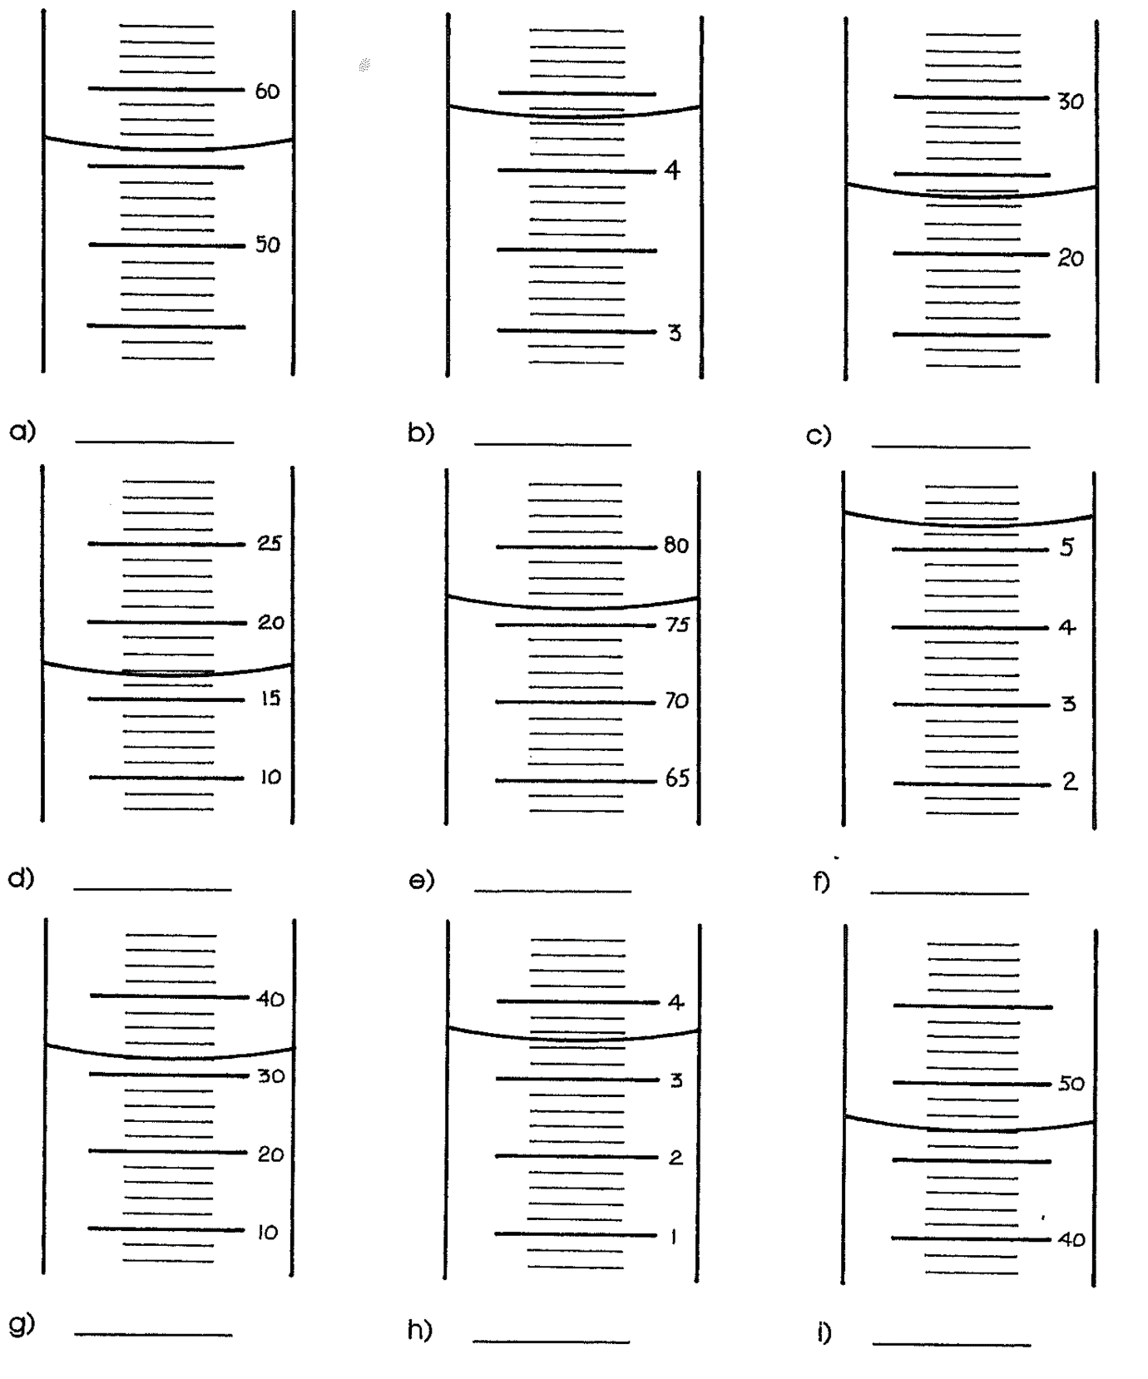**For each, record the volume with absolute uncertainty in mL.**

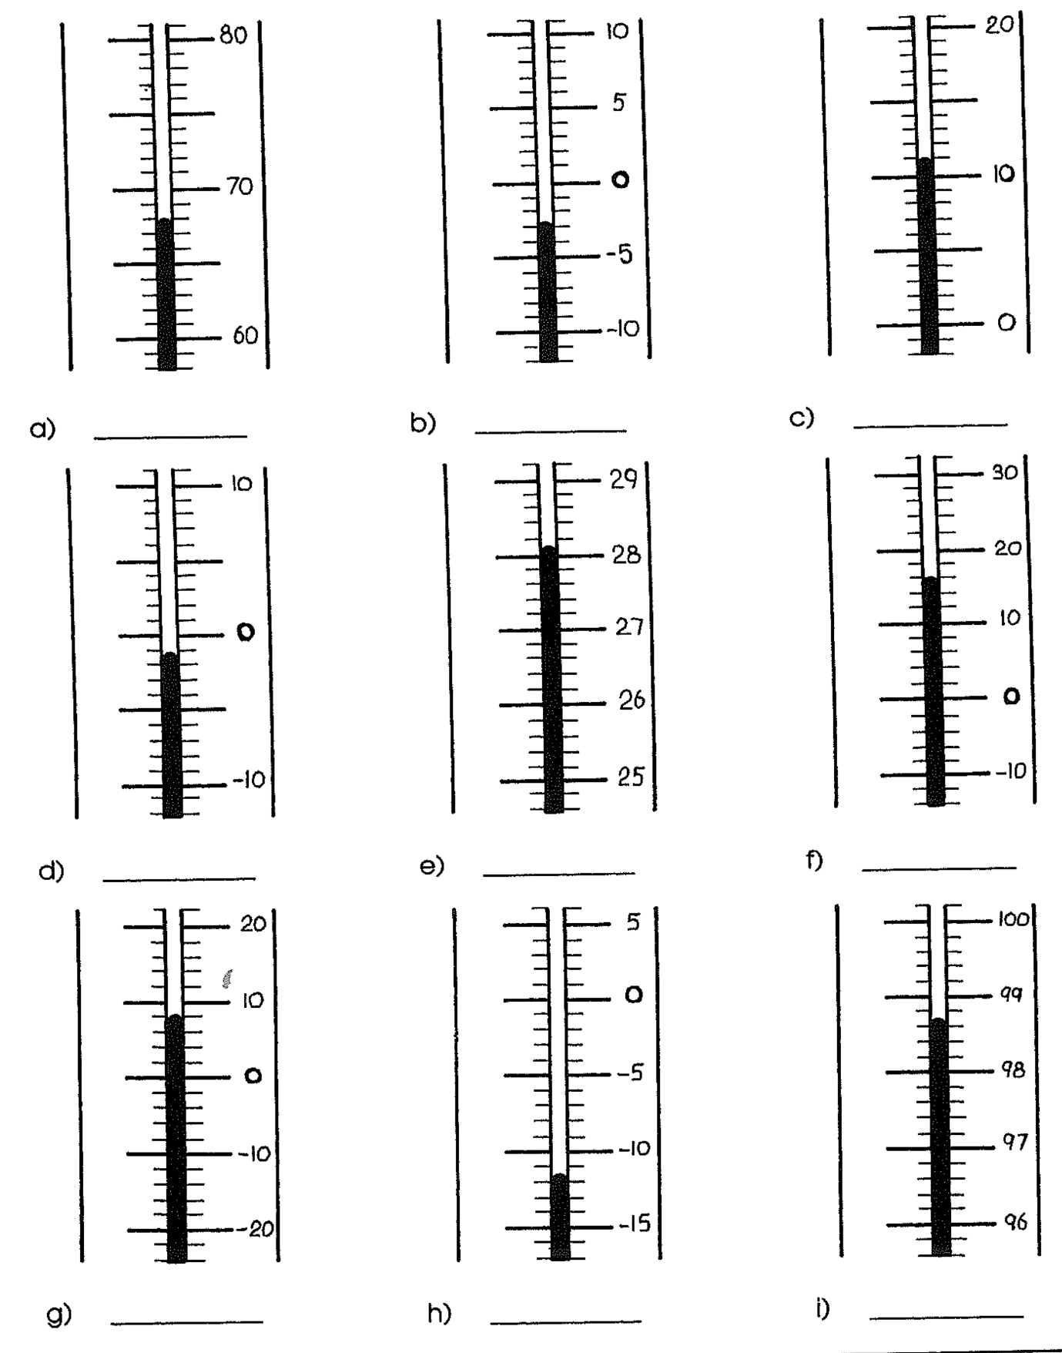**For each thermometer record the temperature with absolute uncertainty in °C.**

## **Percentage Uncertainty - Ext**

A measurement with a smaller absolute uncertainty is a better measurement, but it is particularly important how large the absolute uncertainty is relative to the measurement itself. In order to compare different uncertainties or to use uncertainty in calculations we convert uncertainty to percentage uncertainty.

Percentage uncertainty is the absolute uncertainty as a percentage of the measurement.

$$Percentage uncertainty=\frac{absolute uncertainty}{measurement}×100$$

12 ± 0.5 m

12 m ± 4.17%

Note that the measurement has its units while the percentage uncertainty has the percentage symbol.

Calculate the percentage uncertainty for each of the measurement on the previous two pages.

****Measurement exercise****

****Equipment****

* **100 mL beaker**
* **50 mL measuring cylinder**
* **Coloured water**
* **Scale**
* **Small stone**
* **1 m ruler**
* **trundlewheel**

****Method****

1. **Record the mass of the stone with absolute uncertainty.**
2. **Record the width of the desk with absolute uncertainty.**
3. **Pour approximately 20 mL of coloured water into the beaker, record the volume with absolute uncertainty.**
4. **Pour the water from the beaker into the measuring cylinder, record the volume with absolute uncertainty.**
5. **Measure width of classroom using the trundle wheel.**
6. **(EXT) Calculate the percentage uncertainty for each measurement.**

|  |  |  |  |
| --- | --- | --- | --- |
|  | **Measurement** | **Absolute uncertainty** | **Percentage uncertainty** |
| **Mass of stone** |  |  |  |
| **Width of desk** |  |  |  |
| **Volume in beaker** |  |  |  |
| **Volume in measuring cylinder** |  |  |  |
| **Width of classroom** |  |  |  |

## **Significant Figures**

Calculated numbers with many digits are often rounded off. The convention of rounding off to two decimal places doesn’t work well with very large or very small numbers.

0.000433632994576 rounds to 0.00

21348637993 rounds to 21348637993

A more flexible and consistent way of rounding is to round to a certain number of ‘significant figures’. To do this we must understand which digits count as significant figures and which don’t.

1. Non-zero digits are significant
2. Zeroes that are BOTH at the end of a number AND after the decimal point are significant
3. Digits between significant digits are significant

Round the following numbers to three significant figures:

1. 0.002345678 mL
2. 40695 kg
3. 4.0223 x 102 m
4. 43050 mm

## **Scientific Notation - EXT**

Extremely large and extremely small numbers take up a lot of space when written in full with all the zeroes. For easier handling of these numbers they are written as a number between 1 and 10 multiplied by a power of 10, this is known as scientific notation.

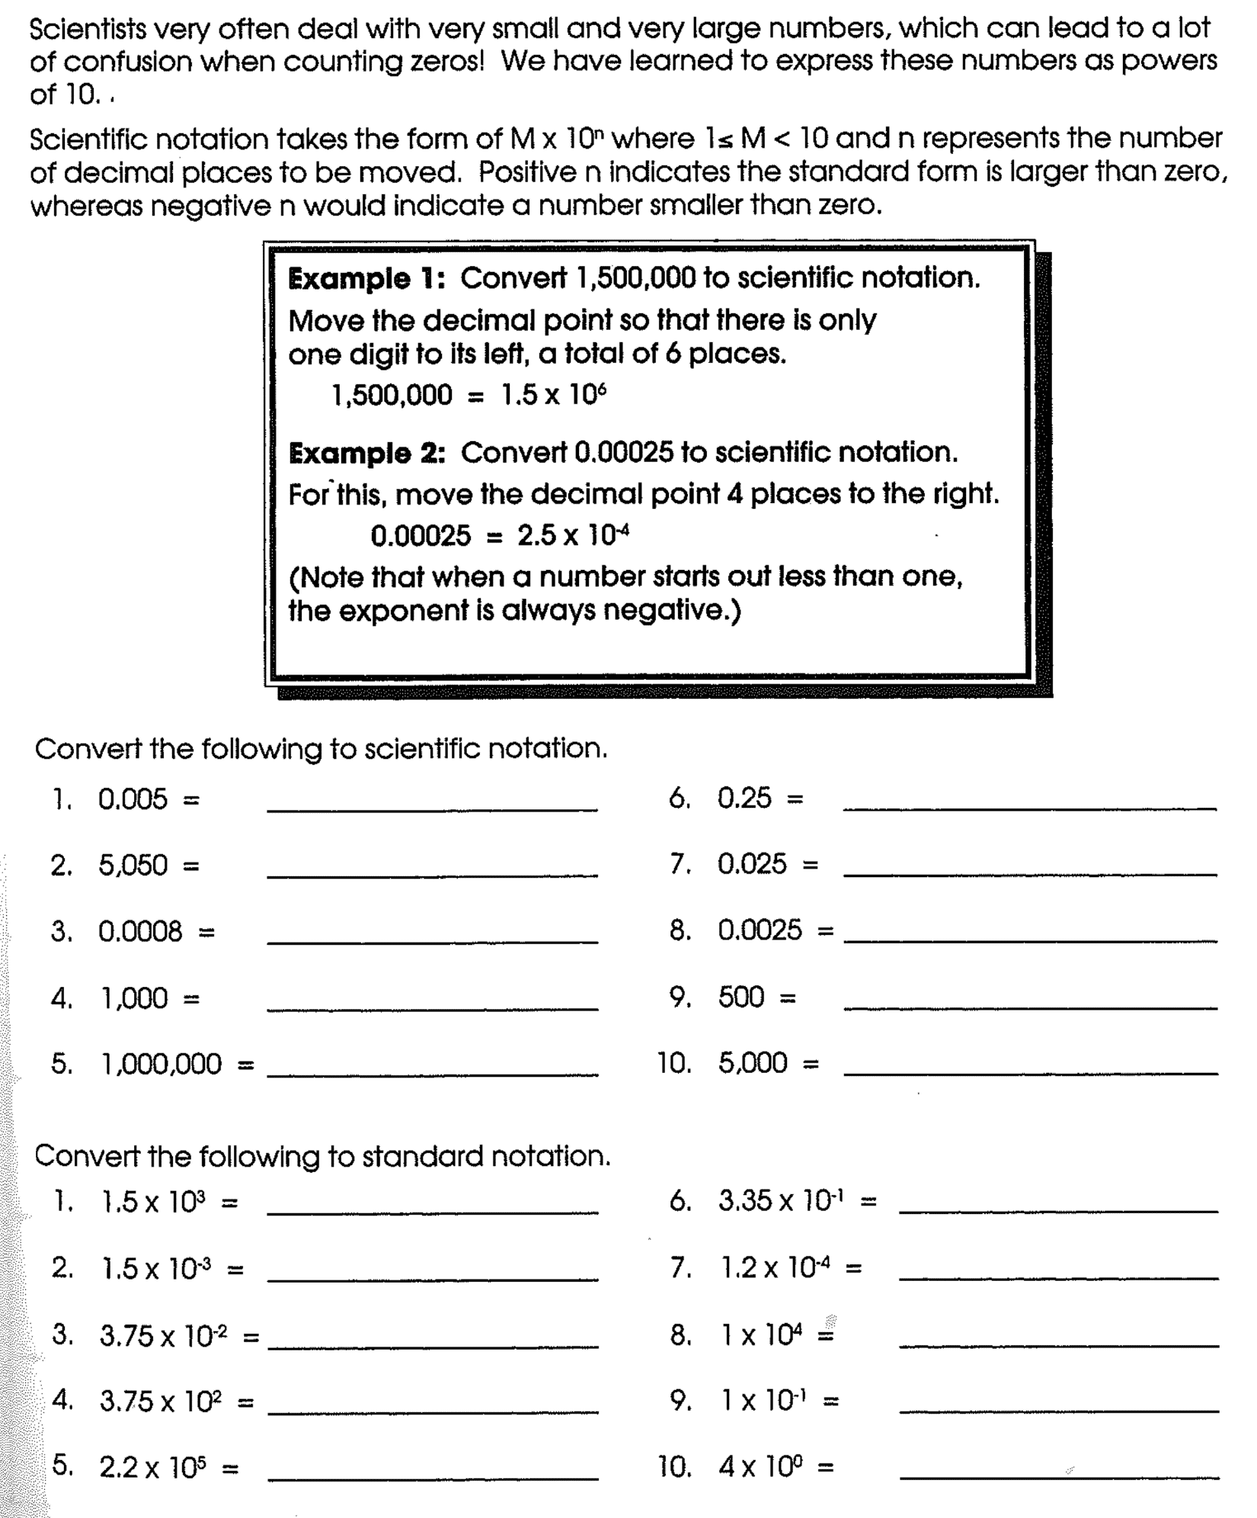

## **SI Units - Ext**

In Australia we measure distances in millimetres, metres and kilometres while in the US they measure distances in inches, feet and miles. Throughout history confusion over units has caused many disasters including:

* 1628 Vasa, possibly the most powerful warship in the world immediately sank on her maiden voyage – possibly caused by Swedish feet being 12” while Amsterdam feet are 11”.
* 1999 Mars Climate Orbiter, destroyed in Mars’ atmosphere – NASA was working in metric units with a contractor using imperial units.
* 2003 bridge between Germany and Switzerland in Laufenburg, built from each country to meet in the middle, one side was 54cm higher than the other – Germany and Switzerland measure sea level differently

With the aim of preventing such problems an International System of Units was devised in 1960 so that the same units were used worldwide. This system has been officially adopted by everyone except Myanmar, Liberia and the US.

For our purposes we should ensure the following:

* Time is measured in seconds (s)
* Length is measured in metres (m)
* All derived quantities are in matching units so:
* Speed/velocity are measured in metres per second (m/s or m s-1)
* Acceleration is measured in metres per second per second m/s2 or m s-2)

**Speed and velocity are commonly measured in km/h, this will have to be converted into m/s for most equations.**

$$m s^{-1}\underset{→}{×3.6}km h^{-1}$$

$$km h^{-1}\underset{→}{÷3.6}m s^{-1}$$

**Convert ;**

**1. 60 km/h to m/s**

**2. 27.78 m/s to km/h**

## **SI Prefixes - Ext**

SI units are often modified by prefixes to make them larger or smaller. These prefixes mean the same thing regardless of what unit they are applied to.

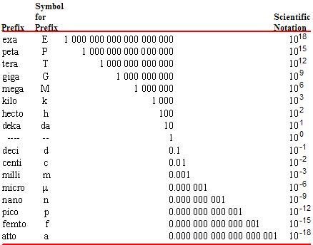

(Ed Vitz, 2019)

For our purposes you are expected to know ‘kilo’ and ‘milli’.

Examples

1. Convert 34 mm to m.

2. Convert 2.4 kL to mL.

Converting units of time ̈Units of time are not based on the metric system because they relate to the Earth’s rotation on its axis (day) and its revolution around the Sun (year).

## Examples

## 1. Convert 2 h to s.

## 2. Convert 1 year to s.

# Velocity

**Flashcard Vocab**: displace, rate, velocity

* Like speed, **velocity** measures how fast something is moving. But velocity is a **vector**, which means it takes direction into account.
  + **Velocity is the rate of change of displacement**.
* It tells us by how much an object is being **displaced** per unit of time.
  + As for speed, the standard units for **velocity** are **metres per second** (**m/s**), and we also use km/h.
  + A **direction** must be included to property describe a velocity.
* Average velocity is found by dividing the displacement by the elapsed time.

Note that “s” in a formula stands for “di**s**placement” (from a Latin word related to “space”).

Hint: NEVER use the symbol “s” for speed! Always write the full word, “speed”.

* A picture containing bird

  Description automatically generatedA triangle can be used to find each quantity.
$$s= v_{av} × t$$

$$t= \frac{s}{v_{av}}$$

* Note: For an object moving in a straight line in one direction, the calculations for speed and velocity will give the exact same answer, except that velocity includes the direction of travel.

In your own words, explain the difference between **speed** and **velocity**.

\_\_\_\_\_\_\_\_\_\_\_\_\_\_\_\_\_\_\_\_\_\_\_\_\_\_\_\_\_\_\_\_\_\_\_\_\_\_\_\_\_\_\_\_\_\_\_\_\_\_\_\_\_\_\_\_\_\_\_\_\_\_\_\_\_\_\_\_\_\_\_\_\_\_\_\_

\_\_\_\_\_\_\_\_\_\_\_\_\_\_\_\_\_\_\_\_\_\_\_\_\_\_\_\_\_\_\_\_\_\_\_\_\_\_\_\_\_\_\_\_\_\_\_\_\_\_\_\_\_\_\_\_\_\_\_\_\_\_\_\_\_\_\_\_\_\_\_\_\_\_\_\_

\_\_\_\_\_\_\_\_\_\_\_\_\_\_\_\_\_\_\_\_\_\_\_\_\_\_\_\_\_\_\_\_\_\_\_\_\_\_\_\_\_\_\_\_\_\_\_\_\_\_\_\_\_\_\_\_\_\_\_\_\_\_\_\_\_\_\_\_\_\_\_\_\_\_\_\_

\_\_\_\_\_\_\_\_\_\_\_\_\_\_\_\_\_\_\_\_\_\_\_\_\_\_\_\_\_\_\_\_\_\_\_\_\_\_\_\_\_\_\_\_\_\_\_\_\_\_\_\_\_\_\_\_\_\_\_\_\_\_\_\_\_\_\_\_\_\_\_\_\_\_\_\_

## Worked Examples

1. What is the average velocity of a Formula 1 racing car that travels 250 m north in 2.3 s?
2. A car moves 40 km north in 20 minutes. What was its average velocity in km/h?
3. How far could Mrs Smith sprint in 2 min if her average velocity is 7 m/s?
4. Determine the displacement travelled by a Blackbird jet fighter plane in 1 hour if it flies due south with a uniform velocity of 830 m/s.
5. a) How long would it take for Ian Thorpe to swim a 400 m race if he can swim at 1.81 m/s?

b) Determine Ian Thorpe’s velocity after swimming the 400m race in a 50m pool.

**Ext: EXAMPLE:**

1. A boy rides his bike 300 m south in 2 mins 30 seconds, then turns around and rides 135 m back north for 1 minute 25 seconds.
2. What is the total distance travelled?
3. What is the average speed?
4. What is the displacement?
5. What is the average velocity?
6. A girl rides her bike 300m south in 2 mins 30 seconds, then turns east and cycles 135 m for

1 minute 25 seconds.

1. What is the total distance travelled?
2. What is the average speed?
3. What is the displacement?
4. What is the average velocity?

## Activity: Dice Walk (optional)

Follow your teacher’s instructions for this activity, using the worksheet provided.

## Exercise Set IIB

Collect the review worksheet, complete it, and mark your work using the answers provided.

|  |  |
| --- | --- |
| Worksheet: “Velocity” |  |

|  |  |
| --- | --- |
| Lab: Using a motion sensor (cf. O10.p223) |  |
| Follow your teacher’s instructions and the steps on the lab sheet. |

**Questions:**

1. A runner jogs for 45 minutes at 12 km/h, then does a cool-down walk for 10 minutes at 5 km/h. If the runner continually went in a straight line, for his entire trip, what was his displacement? If, after 45 minutes, the runner turned around and walked in the opposite direction for his cool-down, what would then be his displacement?
2. A snowmobile travels south at 65 km/h for 30 minutes, turns west, and continues traveling at 50 km/h for an hour.
3. What distance did the snow mobile cover?
4. What was the displacement of the snowmobile?
5. What was its average speed?
6. What was its average velocity? (extension)
7. A cyclist rides 15 km due east, then makes a 90 degree turn north and continues traveling for 20 km. He completes the journey in 2 hours and 10 mins.
8. Calculate his average speed.
9. Calculate his average velocity. (extension)

**Answers:**

1. 9 km + 0.83 km = 9.83 km (one direction) 9 km – 0.83 km = 8.17 km (change direction)

2a) Distance = 82.5 km b) Displacement = 59.6 km S570W c)Average Speed = 55 km/h

Average Velocity= 39.76 km/h 2370

3. a) 16.15 km.-1 or 4.49 m s-1

b) 11.54 km.h-1 or 3.2 m s-1

MORE PRACTISE of MIXED SPEED AND VELOCITY

1. An athlete runs 1500 m in 4 minutes. Calculate the average speed of the athlete in m s-1
2. An aircraft is travelling at 20 m s-1. How far does it travel in 2 minutes?
3. A sprinter runs once around a circular track of 400 m in 57 seconds.
4. Calculate the athletes average speed.
5. Calculate the athletes average velocity.
6. A car travels 35 km North, then 75 km South in a time of 2 hours.
7. What is the total distance travelled?
8. What is the average speed?
9. What is the displacement?
10. What is the average velocity?
11. A train travels in a straight line from one station to the next at 40 km h-1, then it returns at 60 km h-1. If the two stations are 2km apart, compare the average velocity and the average speed for the total journey.

**Answers:**

1. 6.25 m s-1 2. 2400 m
2. a) 7.02 m s-1 b) 0 m.s-1
3. a) 110 km b) 55 km h-1 c) 40 km S d) 20 km h-1 S
4. Average velocity = 0 km h-1 because returned to starting point, so displacement = 0 km.

Average speed = 48 km h-1

## **Displacement-Time Graphs**

Movement of an object can be represented graphically; most common form is a displacement/time graph. This plots the position of an object relative to a point in space over time.

For our purposes we will limit these graphs to one-dimensional motion; forwards and backward OR up and down OR left and right OR North and South OR East and West. These graphs can be applied to 2D or even 3D motion but it makes interpretation much more difficult.

To interpret these graphs it is helpful to break them into straight-line segments. A straight line shows a constant state of motion.

We must understand the following:

Gradient: \_\_\_\_\_\_\_\_\_\_\_\_\_\_\_\_\_\_\_\_\_\_\_\_\_\_\_\_\_\_\_\_\_\_\_\_\_\_\_\_\_\_\_\_\_\_\_\_\_\_\_\_\_\_\_\_\_\_\_\_\_\_\_\_\_\_\_\_\_\_\_\_\_\_\_\_\_\_\_

Horizontal flat line: \_\_\_\_\_\_\_\_\_\_\_\_\_\_\_\_\_\_\_\_\_\_\_\_\_\_\_\_\_\_\_\_\_\_\_\_\_\_\_\_\_\_\_\_\_\_\_\_\_\_\_\_\_\_\_\_\_\_\_\_\_\_\_\_\_\_\_\_\_\_\_\_

Points touching the x-axis: \_\_\_\_\_\_\_\_\_\_\_\_\_\_\_\_\_\_\_\_\_\_\_\_\_\_\_\_\_\_\_\_\_\_\_\_\_\_\_\_\_\_\_\_\_\_\_\_\_\_\_\_\_\_\_\_\_\_\_\_\_\_\_\_\_\_

Positive slope above the x-axis: \_\_\_\_\_\_\_\_\_\_\_\_\_\_\_\_\_\_\_\_\_\_\_\_\_\_\_\_\_\_\_\_\_\_\_\_\_\_\_\_\_\_\_\_\_\_\_\_\_\_\_\_\_\_\_\_\_\_\_\_\_\_

Negative slope above the x-axis: \_\_\_\_\_\_\_\_\_\_\_\_\_\_\_\_\_\_\_\_\_\_\_\_\_\_\_\_\_\_\_\_\_\_\_\_\_\_\_\_\_\_\_\_\_\_\_\_\_\_\_\_\_\_\_\_\_\_\_\_\_

Negative slope below the x-axis: \_\_\_\_\_\_\_\_\_\_\_\_\_\_\_\_\_\_\_\_\_\_\_\_\_\_\_\_\_\_\_\_\_\_\_\_\_\_\_\_\_\_\_\_\_\_\_\_\_\_\_\_\_\_\_\_\_\_\_\_\_

Positive slope below the x-axis: \_\_\_\_\_\_\_\_\_\_\_\_\_\_\_\_\_\_\_\_\_\_\_\_\_\_\_\_\_\_\_\_\_\_\_\_\_\_\_\_\_\_\_\_\_\_\_\_\_\_\_\_\_\_\_\_\_\_\_\_\_\_

**Examples**

1. Describe motion of an object’s motion as shown by above graph.
2. Determine the velocity at:
   1. 30s
   2. 52s
   3. 70s
   4. 100s.
3. What is the object’s final displacement?
4. What distance did the object travel?

**Answers**

2. a) 0.5 m s-1 forwards b) 1 m s-1 backwards c) 0 m d) 0.5 ms-1 forwards 3. 25 m forwards 4. 45 m

1. Describe motion of an object’s motion as shown by above graph. It is a car that is initially travelling West.
2. Determine the velocity at:
   1. 7s
   2. 12s
   3. 17s
   4. 27s.
3. What is the object’s final displacement?
4. What distance did the object travel?

**Answers**

2. a) 0.6 m s-1 W b) 0 m s-1 c) 2.4 m s-1 E d) 1.2 m s-1 W 3. 0 m 4. 24 m

# Acceleration

**Flashcard Vocab**: accelerating, acceleration, acceleration due to gravity, constant velocity, decelerating, final velocity, free fall, “g-force”, initial velocity, terminal velocity

## Demo: Fan cart acceleration (with video analysis of motion)

Describe the motion of the car.

\_\_\_\_\_\_\_\_\_\_\_\_\_\_\_\_\_\_\_\_\_\_\_\_\_\_\_\_\_\_\_\_\_\_\_\_\_\_\_\_\_\_\_\_\_\_\_\_\_\_\_

What is happening to the amount of displacement each second?

\_\_\_\_\_\_\_\_\_\_\_\_\_\_\_\_\_\_\_\_\_\_\_\_\_\_\_\_\_\_\_\_\_\_\_\_\_\_\_\_\_\_\_\_\_\_\_\_\_\_\_

Sketch a simple displacement-time graph of the cart’s *acceleration*.

## Activity: How fast is your car?

The graph plots the time it takes cars to accelerate from 0 to 100 km/h for the past 100 years.

Why are the fastest cars plotted near the bottom?

\_\_\_\_\_\_\_\_\_\_\_\_\_\_\_\_\_\_\_\_\_\_\_\_\_\_\_\_\_\_\_\_\_\_\_\_\_\_\_\_\_\_\_\_\_\_\_\_\_\_\_\_\_\_\_\_\_\_\_\_\_\_\_\_\_\_\_\_\_\_\_\_\_\_\_\_

What is the general trend over the decades? \_\_\_\_\_\_\_\_\_\_\_\_\_\_\_\_\_\_\_\_\_\_\_\_\_\_\_\_\_\_\_\_\_\_\_\_\_\_\_\_

Estimate how quickly you think your family car could accelerate from 0 to 100 km/h! \_\_\_\_\_\_\_\_\_

* **Acceleration** is speeding up or slowing down.
  + Acceleration measures how quickly an object’s speed (or velocity) changes.
  + E.g. the car in the example is increasing its speed by 12 km/h every second:

* **Acceleration** is defined as **the rate of change of velocity** of an object.
  + Like velocity, acceleration is a **vector**, so it must have magnitude and **direction**.
* To calculate acceleration, we need to know the change in speed We use these symbols:

Hint: Write “curly v” and “curly u” so that you don’t get the letters mixed up!

* + *u* = initial velocity (starting speed)
  + *v* = final velocity (finishing speed)
* Change in velocity will always be the final velocity minus the initial velocity, *v – u*.
* To find out how quickly velocity changes, i.e. the rate of change, we just divide by time, so:

where *a* is the letter we use for acceleration.

* + Because we are dividing a change in velocity (m/s) by a time (s), the units of measurement are **metres per second per second**, which is $\frac{\text{m/s}}{\text{s}}$ = m/s/s or just **m/s2 but preferably ms-2**.
* Acceleration can be positive, negative, or zero:
  + **positive** acceleration means “speeding up”, or **accelerating**;
  + **negative** acceleration means “slowing down”, or **decelerating**; and
  + **zero** acceleration means the object has a **constant velocity**.

## Worked Examples

1. A Nissan 300ZX can produce an average acceleration of nearly 20 m/s2. Explain what this acceleration means.  
   \_\_\_\_\_\_\_\_\_\_\_\_\_\_\_\_\_\_\_\_\_\_\_\_\_\_\_\_\_\_\_\_\_\_\_\_\_\_\_\_\_\_\_\_\_\_\_\_\_\_\_\_\_\_\_\_\_\_\_\_\_\_\_\_\_\_\_\_\_\_\_\_\_\_\_\_\_\_\_\_\_\_\_\_\_\_\_\_\_\_\_\_\_\_\_\_\_\_\_\_\_\_\_\_\_\_\_\_\_\_\_\_\_\_\_\_\_\_\_\_\_\_\_\_\_\_\_\_\_\_\_\_\_\_\_\_\_\_\_\_\_\_\_\_\_\_\_\_\_\_\_\_\_\_\_\_\_\_\_\_\_\_\_\_\_\_\_\_\_\_\_\_\_\_\_\_\_\_\_\_\_\_\_\_\_\_\_\_\_\_\_\_\_\_\_\_\_\_\_\_\_\_\_\_\_\_\_\_\_\_\_\_\_\_\_\_\_\_\_\_\_\_\_\_\_\_\_\_\_\_\_\_\_\_\_\_\_\_\_\_\_\_\_\_\_\_
2. While accelerating, an object changes its velocity from 24.48 m/s to 54.00 m/s over a time period of 10.15 s. What is the value of this acceleration?
3. A powerful race car accelerates from rest to 36 m/s in 6.5 seconds. Find the average acceleration of the car.
4. A car moving at 506 m/s reaches rest in 5.6 s, what is the average deceleration?

## Practice Examples

1. A train moving at 15.0 m/s speeds up to 35.0 m/s over a period of exactly one minute. Calculate its acceleration.

2. A skydiver is falling with a velocity of 60.0 m/s when her parachute opens. Her velocity 3.50 seconds later is 18.0 m/s. What acceleration did she experience?

3. A car, starting from rest, reaches a speed of 45 m/s in 8 seconds.   
 What was its acceleration?

4. A drag car can accelerate from rest to 180 km/h in 8.00 seconds.   
a) What was its final velocity in m/s?   
b) What acceleration does it experience?

* We can turn the acceleration formula around to give us final velocity:

$$v=u+at$$

## Worked Example

An object is travelling along with a velocity of 2.44 m/s when it accelerates at 1.97 m/s2 for a time period of 7.47 s. What is the final velocity of this object?

## Practice Examples

1. A motorcyclist riding at 14.0 m/s accelerates at 3·50 m/s2 for 7.00 seconds.   
a) What is her final velocity?  
b) Has she exceeded the 100 km/h speed limit?

2. A racing car can accelerate at 8.00 m/s2 during a short race.   
What final velocity did it attain in a sprint lasting 6·55 seconds?

Practice Calculations

1. A car increases its velocity from 3ms-1 north to 18 m s-1 north in 3 seconds. Find its acceleration assuming that it is constant.
2. A train moves east from rest to a uniform velocity of 12 m s-1 in 8 seconds. What is its average acceleration?
3. A car can accelerate at 8 m s-2. How long will it take to reach a velocity of 42 m s-1 from a standing start?
4. A car is uniformly accelerated at 4 m s-2. What it its change in velocity every second?
5. A sports car has an acceleration of 16.5 m s-2. If it is traveling west at 30m s-1 and it accelerates for 5 seconds, what is its new velocity?
6. A vehicle is moving east with a uniform velocity of 20m s-1. It is then accelerated uniformly at 2 m s-2 for 12 seconds. What is its velocity after 12 seconds?
7. An object is moving with a uniform velocity of 20ms-1 south. It is then decelerated uniformly at 2 m s-2 for 5 seconds. Find the velocity of the body after this time.
8. A motor scooter has a constant acceleration of 8 m s-2. If it takes the scooter 2 seconds to travel 40 metres, what was its initial velocity? (ext and adv)
9. An object changes its velocity from 30 m s-1 west to 18 m s-1 west in 6 seconds. What it its acceleration?
10. A car takes 6 seconds to be uniformly decelerated to rest from 35 m s-1. What is the deceleration?
11. A motorcycle is moving north with a velocity of 17 m s-1. For 24 seconds it undergoes a uniform deceleration of 0.3 m s-2. What is its new velocity after this time?
12. How long does a ball thrown vertically upwards at 6.00 m s-1 take to return to the thrower’s hand?

# Graphical user interface, text, application, chat or text message Description automatically generatedAcceleration due to gravity

* If a stationary rock gets dropped from a height, it will steadily gain velocity as it falls.
* Each second, it gains about 10 m/s (see diagram).
* If we ignore friction, its acceleration is constant and it will get faster and faster until it hits the ground. In reality, air resistance will slow it’s rate of acceleration until it reaches its **terminal velocity**, the highest speed it will reach in free fall.
* The acceleration of falling objects is caused by the force of **gravity**.
* On Earth, the **acceleration due to gravity** is *g* = 9.80 m/s2.
* Note: All falling objects accelerate towards the ground (down) at the same rate, regardless of their mass (strictly true only in a vacuum).

|  |  |
| --- | --- |
| Watch: “Falling feather in a vacuum” |  |

## Worked Example

If a penny is dropped from the Empire State Building, which is 381 m tall, with what speed would it strike the ground if it takes 8.82 s to fall? (Ignore the effects of air resistance.)

Since gravity accelerates all masses at the same rate, we don’t need to know the coin’s mass.

Use “*g*” instead of *a* in the formula for calculating final velocity:

$$v=u+gt=$$

## Practice Example

If a 2.00 kg brick is dropped off the edge of a high cliff, what is its speed 2.5 s later (ignoring friction)?

## Demo: Acceleration down the slope (motion sensor)

Describe the effects of (i) the angle of the slope; and (ii) friction on the rate of acceleration down the slope of the cart.

\_\_\_\_\_\_\_\_\_\_\_\_\_\_\_\_\_\_\_\_\_\_\_\_\_\_\_\_\_\_\_\_\_\_\_\_\_\_\_\_\_\_\_\_\_\_\_\_\_\_\_\_\_\_\_\_\_\_\_\_\_\_\_\_\_\_\_\_\_\_\_\_\_\_\_\_

\_\_\_\_\_\_\_\_\_\_\_\_\_\_\_\_\_\_\_\_\_\_\_\_\_\_\_\_\_\_\_\_\_\_\_\_\_\_\_\_\_\_\_\_\_\_\_\_\_\_\_\_\_\_\_\_\_\_\_\_\_\_\_\_\_\_\_\_\_\_\_\_\_\_\_\_

\_\_\_\_\_\_\_\_\_\_\_\_\_\_\_\_\_\_\_\_\_\_\_\_\_\_\_\_\_\_\_\_\_\_\_\_\_\_\_\_\_\_\_\_\_\_\_\_\_\_\_\_\_\_\_\_\_\_\_\_\_\_\_\_\_\_\_\_\_\_\_\_\_\_\_\_

\_\_\_\_\_\_\_\_\_\_\_\_\_\_\_\_\_\_\_\_\_\_\_\_\_\_\_\_\_\_\_\_\_\_\_\_\_\_\_\_\_\_\_\_\_\_\_\_\_\_\_\_\_\_\_\_\_\_\_\_\_\_\_\_\_\_\_\_\_\_\_\_\_\_\_\_

|  |  |
| --- | --- |
| Lab: Measuring g-ball acceleration (cf. O10.p223) |  |
| Follow your teacher’s instructions and the steps on the lab sheet. |

## Exercise Set III: Acceleration

Collect the review worksheet, complete it, and mark your work using the answers provided.

|  |  |
| --- | --- |
| Worksheet: “Acceleration” |  |

# Reaction Time

**Flashcard Vocab**: 2-second rule, braking distance, braking time, reaction time, reaction distance, safe following distance, stopping distance

### Activity: Recording reaction times

Visit **https://humanbenchmark.com/tests/reactiontime** and test your reaction time.  
Record your best time below, and convert it to seconds (¸1000).

Best reaction time (red 🡪 green): in milliseconds: \_\_\_\_\_\_\_\_\_\_

in seconds: \_\_\_\_\_\_\_\_\_\_

What was your best time? What factors might affect your times?

\_\_\_\_\_\_\_\_\_\_\_\_\_\_\_\_\_\_\_\_\_\_\_\_\_\_\_\_\_\_\_\_\_\_\_\_\_\_\_\_\_\_\_\_\_\_\_\_\_\_\_\_\_\_\_\_\_\_\_\_\_\_\_\_\_\_\_\_\_\_\_\_\_\_\_\_

\_\_\_\_\_\_\_\_\_\_\_\_\_\_\_\_\_\_\_\_\_\_\_\_\_\_\_\_\_\_\_\_\_\_\_\_\_\_\_\_\_\_\_\_\_\_\_\_\_\_\_\_\_\_\_\_\_\_\_\_\_\_\_\_\_\_\_\_\_\_\_\_\_\_\_\_

* When driving a car, it takes a fraction of a second or longer to react to a hazard. The longer the reaction time, the longer it will take for the vehicle to stop.
* **Reaction time** is how long it takes a driver to start braking.
* A driver’s reaction time can be increased by:
  + distractions, such as mobile phone, changing music, conversation;
  + influence of alcohol/drugs;
  + driving conditions e.g. heavy rain, fog, day/night; and
  + age and experience.
* **Reaction distance** is how far the vehicle travels before the driver starts braking.
* **Braking distance** is how far the vehicle travels during braking to come to a complete stop.
* The total **stopping distance** is given by:

**stopping distance = reaction distance + braking distance**

* **Safe following distance** takes reaction time into account.
* Recent research showed that **nearly 28.3 per cent of WA car crashes** between July 2016 to June 2017 were **due to nose-to-tail driving** (tailgating), which usually ended up in a nasty rear-end collision. *Many motorists drive dangerously close to the vehicle in front.*
  + *A motorist is usually at fault if they are involved in a rear-end accident!*
  + In normal driving conditions, drivers should **leave a 2-second gap** behind the vehicle in front. This is called the **2-second rule**.

|  |  |
| --- | --- |
| Watch: “Following distance” (Road Safety Commission) |  |

To calculate reaction distance, we can use

$s=ut_{R}$ where *tR* = **reaction time**

To calculate braking distance (displacement), we can use:

$s=\frac{1}{2}ut_{B}$ where *tB* = **braking time**

Note: This rule is only true if the vehicle comes to a complete stop.

## Worked Examples

1. If a person’s average reaction time to apply brakes when a car pulls out in front of them is 0.4 s, determine the *reaction distance* if the car was initially travelling at:
   1. 60 km/h;

Hint: Must convert km/h to m/s to get distances in m!

* 1. 100 km/h.

Express your answers in car lengths (1 car length = 4.5 m).

1. A car is cruising at 72 km/h.
   1. How far will it travel when braking from this speed if it takes 5 s to stop?
   2. What is this distance called? \_\_\_\_\_\_\_\_\_\_\_\_\_\_\_\_\_\_\_\_\_\_\_\_\_
2. Calculate the stopping distance of a family car initially travelling at 100 km/h where the driver takes 1.5 s to react and brakes for 4.5 s in order to stop.

Practice Calculations

1. A car increases its velocity from 3ms-1 north to 18 m s-1 north in 3 seconds. Find its acceleration assuming that it is constant.
2. A train moves east from rest to a uniform velocity of 12 m s-1 in 8 seconds. What is its average acceleration?
3. A car can accelerate at 8 m s-2. How long will it take to reach a velocity of 42 m s-1 from a standing start?
4. A car is uniformly accelerated at 4 m s-2. What it its change in velocity every second?
5. A sports car has an acceleration of 16.5 m s-2. If it is traveling west at 30m s-1 and it accelerates for 5 seconds, what is its new velocity?
6. A vehicle is moving east with a uniform velocity of 20m s-1. It is then accelerated uniformly at 2 m s-2 for 12 seconds. What is its velocity after 12 seconds?
7. An object is moving with a uniform velocity of 20ms-1 south. It is then decelerated uniformly at 2 m s-2 for 5 seconds. Find the velocity of the body after this time.
8. A motor scooter has a constant acceleration of 8 m s-2. If it takes the scooter 2 seconds to travel 40 metres, what was its initial velocity? (ext and adv)
9. An object changes its velocity from 30 m s-1 west to 18 m s-1 west in 6 seconds. What it its acceleration?
10. A car takes 6 seconds to be uniformly decelerated to rest from 35 m s-1. What is the deceleration?
11. A motorcycle is moving north with a velocity of 17 m s-1. For 24 seconds it undergoes a uniform deceleration of 0.3 m s-2. What is its new velocity after this time?
12. How long does a ball thrown vertically upwards at 6.00 m s-1 take to return to the thrower’s hand?

**Answers**

1. 5 m.s-2 2. 1.5 m.s-2 3. 5.25 s4. 4 m.s-1  5. 112. m.s-1 6. 44 m.s-1 7. 10 m.s-1 8. 12 m.s-1 9. -2 m.s-2 10. -5.83 m.s-2 11. 9.8 m.s-1 12. 1.22 s

## **Ticker Timers - Ext**

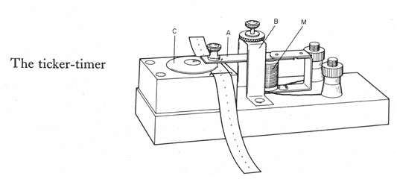

(https://swh-826d.kxcdn.com/wp-content/uploads/2010/05/ticker-timer.png)

Device for measuring motion of an object. Tape pulled through under a hammer that strikes at regular time intervals.

Alternating current mains electricity in Australia alternates with a frequency of **50 Hz (50 times per second).** This causes the hammer to strike 50 times a second, leaving **0.02 seconds** between blows.

Every time the hammer strikes the tape through carbon paper it leaves a dot on the tape.

If the dots are closer together, the object is moving more slowly, if the dots are further apart the object is moving more quickly.

Speed can be calculated off the tape (or section of tape) using the normal equation:

$$speed=\frac{distance}{time}=\frac{distance from first dot to last dot}{number of gaps ×0.02}$$

Acceleration can also be calculate using the normal equation:

$$a=\frac{v-u}{t}$$

v and u must be separately calculated for two different segments on the tape.

## **Acceleration Practical:**

Task: Using the ticker timers, produce a tape recording the motion of the trolley down the slope. Each student must produce their own tape.

Using your tape:

Mark off 4 x 5 dot intervals.

Determine the average velocity for each time interval.

Using the first and last time interval determine the acceleration of the trolley.

NOTE: For a time interval the average velocity will be the instantaneous velocity mid-time of that interval.

For each of the following tapes:

1. Describe the motion shown
2. Calculate the average speed for the motion
3. Calculate the acceleration comparing the first interval and the last interval

## **Displacement and Acceleration – Ext**

$$s=ut+1/{2 }at^{2}$$

**Where:**

*s*-displacement (m)

*u*-initial velocity (m/s)

*a*-acceleration (m/s2)

*t*-time (s)

## **NOTE: $s=v x t$ MAY NOT BE USED.**

A vehicle is moving east with a uniform velocity of 20 m s-1 and then accelerates uniformly at

4 m s-2 for 5 seconds. What is its displacement after 5 seconds?

An object is moving with a uniform velocity of 20 m s-1 south. It is then retarded at 2 m s-2 for 12 seconds. Find the displacement of the body after this time.

**Questions:**

1. How far does a car travel if he pulls off from a traffic light and accelerates at 3 m s-2 for 4 seconds?
2. How far will a car travelling at 60 km/h take to stop if it decelerates at 5 m s-2 for 3.5 seconds?
3. What is a drag car’s acceleration if from a standing start it covers 100 m in 2.5 seconds.
4. What is a car’s displacement if it accelerates from 120 km/h for 5 seconds at an acceleration of

2.5 m s-2?

**Answers**

1. 24m 2. 27.7m 3. 32 ms-2 4. 197 m

## **Revision for Mid-Topic Test**

1. Define (and explain the difference between) distance and displacement and state whether each is a vector or scalar quantity.
2. What is meant by the terms vector and scalar quantities?
3. Find the distance and displacement of:
4. A tennis ball rolls 4 m to the left and then bounces back 6 m.
5. A man walks 3 km south and then 2km west.
6. Explain the difference between speed and velocity.
7. A runner completes 3 laps of a 200 m circular track in 104 s.
8. Calculate the average speed.
9. Calculate the average velocity
10. A wookie runs 16.5 m south in 2.0 s then 18.9 m North in 3.1 s.
    * 1. What is the distance travelled?
      2. What is the displacement?
      3. What is the average speed?
      4. What is the average velocity?
      5. If the fineness of the scale used to measure the length and time were 0.05 m and 0.02 s respectively, determine the absolute and percentage uncertainty of the lengths and times measured.
11. A soccer ball was kicked towards the goals 8 m away. If the ball reached the catcher in 1.2 s, what was the average speed of the ball?
12. A snail crawled for 15 minutes in a straight line. If the snail could maintain an average velocity of 0.01 m s-1, how far did the snail get?
13. A jet plane travels at a constant velocity of 580 m s-1 for 2 km. How long does this take?
14. Define acceleration, write the formula for calculating it and state the units it is measured in.
15. Mr Magoo’s combie van can reach a velocity of 60 kmph in 1 minute from a standing start. What is the van's acceleration?
16. How long would it take a car to change from 10 m s-1 to 20m s-1 if it could accelerate at 2.5 m s-2?
17. How far would a parachutist fall in the first 3.5 seconds? (a = 9.8 m s-2, u = 0 m s-1) EXT
18. What is deceleration?
19. What is the deceleration of a cyclist if he slows down from 8 m s-1 to rest in 10 s?
20. An object decelerates at 8 m s-2 over 5 seconds. If its initial velocity was 60 m s-2 what is its final velocity?
21. How far does an object travel if it starts at 6ms-1 and accelerates at a constant rate of

2 m s-2 for 9 seconds? EXT

1. An X-Wing fighter is travelling horizontally at 31.0 m s-1 when it engages its turbo thrusters for 3.51 s. at the end of this time, its velocity is 273 m s-1. Calculate:
2. The acceleration.
3. The distance travelled while accelerating.EXT
4. How long does it take a car to cover 90 m from the traffic lights if it accelerates at 5 m s-2?
5. Draw a ticker tape that shows:
6. constant velocity followed by rapid deceleration
7. rapid acceleration followed by slow deceleration.
8. Two timer tapes were analysed and the following information was recorded:

Tape Intervals (spaces on tape) Length

1 5 34 mm

2 12 50 mm

1. How long did the motion on each tape last for?
2. What was the average velocity recorded on each tape in m s-1?
3. What is the absolute and percentage uncertainty of each measurement?

# Force

**Flashcard Vocab**: contact force, force, net force, non-contact force

## Graphical user interface, text Description automatically generatedDemo: May the force be with you (P10.2nd.p384)

\_\_\_\_\_\_\_\_\_\_\_\_\_\_\_\_\_\_\_\_\_\_\_\_\_\_\_\_\_\_\_\_\_\_\_\_\_\_\_\_\_\_

\_\_\_\_\_\_\_\_\_\_\_\_\_\_\_\_\_\_\_\_\_\_\_\_\_\_\_\_\_\_\_\_\_\_\_\_\_\_\_\_\_\_

\_\_\_\_\_\_\_\_\_\_\_\_\_\_\_\_\_\_\_\_\_\_\_\_\_\_\_\_\_\_\_\_\_\_\_\_\_\_\_\_\_\_

\_\_\_\_\_\_\_\_\_\_\_\_\_\_\_\_\_\_\_\_\_\_\_\_\_\_\_\_\_\_\_\_\_\_\_\_\_\_\_\_\_\_

\_\_\_\_\_\_\_\_\_\_\_\_\_\_\_\_\_\_\_\_\_\_\_\_\_\_\_\_\_\_\_\_\_\_\_\_\_\_\_\_\_\_

\_\_\_\_\_\_\_\_\_\_\_\_\_\_\_\_\_\_\_\_\_\_\_\_\_\_\_\_\_\_\_\_\_\_\_\_\_\_\_\_\_\_

* A **force** is a **push** or pull in a particular direction.
  + Forces are **vectors**, because they have direction, and are measured in **newtons** (**N**).
  + Forces are either **contact** (e.g. objects pushing each other, hitting, collisions) or  
    **non-contact**, able to act from a distance (e.g. gravity, magnetism).
    - A force itself cannot be seen, but we can observe and measure its effects.
    - Non-contact forces are imagined to act through **fields**, such as a gravitational field.
* More than one force can act on an object at a time, and in any direction. What happens depends on: (i) how strong the forces are; and (ii) their direction.
* Like all vectors, forces may be represented by **vector arrows** which indicate the magnitude (size) of the force, and the direction of the force (e.g. compass bearings, up, down, left or right; right angles to a surface).
* Just like we saw with displacement, **force vectors can be added** to find the **resultant**, which is usually called the **net force**, acting on an object.
  + The **net force** is the combination of all the forces acting on an object.
* **Unbalanced forces** don’t cancel each other out. They can cause a mass to start moving, stop moving, speed up, slow down, change direction, or change shape.
  + In general, **unbalanced forces cause acceleration**.
* **Balanced forces** are those that cancel out and have no effect.
  + If two forces of equal strength act on an object in opposite directions, the forces will cancel, resulting in a net force of zero and no change in motion.

### Exercise

Circle the best answer:

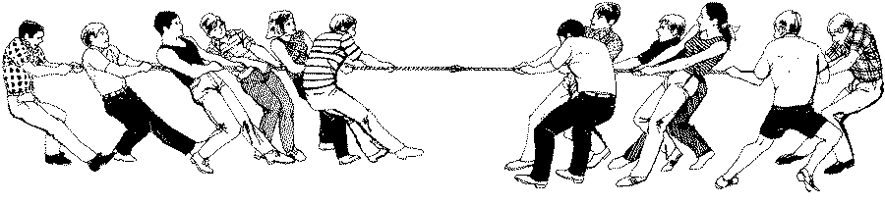

1000 N

900 N

1. The forces shown above are **PUSHING / PULLING** forces.
2. The forces shown above are **WORKING TOGETHER / OPPOSITE FORCES**.
3. The forces are **EQUAL / NOT EQUAL**.
4. The forces **DO / DO NOT** balance each other.
5. The resultant force is **1000 N TO THE RIGHT / 1000 N TO THE LEFT / ZERO**.
6. There **IS / IS NO** motion.

* **Free body diagrams** show all the forces acting on a single object.

### Exercise

The free body diagrams below show different forces acting on a variety of objects. In this exercise, each object is *resting* (i.e., is stationary) on a horizontal, frictionless surface.

* When forces act in the same direction on an object, the size of the net force is equal to the **sum** of the two forces (**add** the numbers).
* When unequal forces act in opposite directions on an object, the size of the net force is the **difference** of the two forces (**subtract** the numbers).

Calculate the net force acting on each object, and draw a resultant vector with a ruler to show the net force, if any. The first one has been done for you. (Note: Not drawn to scale.)

****

7 N

Free body diagrams:

* 1. Book on table
  2. Car driving
  3. C pushing a lawnmower

# Newton’s First Law

**Flashcard Vocab**: drag, friction, inertia, lift, Newton’s first law, Newton’s laws of motion, reaction force, retarding force, sliding friction, static friction, thrust, weight force

* How forces cause changes in motion is described by **Newton’s laws of motion**.

## Demo: Air track – inertia and effect of friction

How would the motion of the cart on the air track when it is *off* compare with when it is *on*? What causes the difference? How does this demonstrate the idea of **inertia**?

**Safety!**

Sliding a cart when the air track is off will damage the track.

\_\_\_\_\_\_\_\_\_\_\_\_\_\_\_\_\_\_\_\_\_\_\_\_\_\_\_\_\_\_\_\_\_\_\_\_\_\_\_\_\_\_\_\_\_\_\_\_\_\_\_\_\_\_\_\_\_\_\_\_\_\_\_\_\_\_\_\_\_\_\_\_\_\_\_\_

\_\_\_\_\_\_\_\_\_\_\_\_\_\_\_\_\_\_\_\_\_\_\_\_\_\_\_\_\_\_\_\_\_\_\_\_\_\_\_\_\_\_\_\_\_\_\_\_\_\_\_\_\_\_\_\_\_\_\_\_\_\_\_\_\_\_\_\_\_\_\_\_\_\_\_\_

\_\_\_\_\_\_\_\_\_\_\_\_\_\_\_\_\_\_\_\_\_\_\_\_\_\_\_\_\_\_\_\_\_\_\_\_\_\_\_\_\_\_\_\_\_\_\_\_\_\_\_\_\_\_\_\_\_\_\_\_\_\_\_\_\_\_\_\_\_\_\_\_\_\_\_\_

\_\_\_\_\_\_\_\_\_\_\_\_\_\_\_\_\_\_\_\_\_\_\_\_\_\_\_\_\_\_\_\_\_\_\_\_\_\_\_\_\_\_\_\_\_\_\_\_\_\_\_\_\_\_\_\_\_\_\_\_\_\_\_\_\_\_\_\_\_\_\_\_\_\_\_\_

|  |  |  |
| --- | --- | --- |
| **1st Law**  **(inertia)** | ***An object remains at rest, or moving at a constant velocity, unless acted upon by an unbalanced, external force.*** | |
| This means that **only an unbalanced force can cause an object’s motion to change**. | | |
| * When *at rest* on a table, a book has a **weight force** pulling it down, and a **reaction force** from the table pushing it up. These two forces are equal in size and cancel. Since the forces are **balanced**, the net force is zero and there is **no change in motion**. * Because the net force is zero, the book’s inertia keeps it stationary. | | * Without the table, the book only has its weight force pulling it down, an unbalanced net force. Therefore, it will **accelerate** down. |
|  | |  |

## Demo: Loose change (P10.p269)

Use the concept of inertia and your understanding of forces to explain your observations.

\_\_\_\_\_\_\_\_\_\_\_\_\_\_\_\_\_\_\_\_\_\_\_\_\_\_\_\_\_\_\_\_\_\_\_\_\_\_\_\_\_\_\_\_\_\_\_\_\_\_\_\_\_

\_\_\_\_\_\_\_\_\_\_\_\_\_\_\_\_\_\_\_\_\_\_\_\_\_\_\_\_\_\_\_\_\_\_\_\_\_\_\_\_\_\_\_\_\_\_\_\_\_\_\_\_\_

\_\_\_\_\_\_\_\_\_\_\_\_\_\_\_\_\_\_\_\_\_\_\_\_\_\_\_\_\_\_\_\_\_\_\_\_\_\_\_\_\_\_\_\_\_\_\_\_\_\_\_\_\_

### **Inertia**

|  |  |
| --- | --- |
| To explain this Newton’s first law, we define **inertia** as the property of mass that resists a change in motion.  The amount of inertia an object has depends on its mass. Note that **inertia is not a force!** It is possessed by all masses. | |
|  | The bucket with the sand is harder to move because it has **more mass** and therefore **more inertia**. |
| An unbalanced force must be applied to any mass in order to **overcome its inertia** and cause it’s state of motion to change. | |

### Friction

|  |  |
| --- | --- |
| **Friction** is a **force** that **opposes motion**. It acts between two surfaces in contact. It is the resistance to the motion of one object moving relative to the other. | |
|  | * Pushing a box at rest sideways won’t move it if the **static friction** balances the applied force. Static friction acts on stationary objects when a force is applied. * Once the box is moving at a **constant velocity**, it will continue to move at the same speed as long as the applied force is exactly balanced by **sliding friction**. Sliding friction is always less than static friction: it is easier to keep an object moving than to start it moving.  If the applied force is removed, then the sliding friction is the only force acting. This net **retarding force** provided by sliding friction will decelerate it until it stops. * **Rolling friction** is less than sliding friction due to the reduced surface area. An object will continue rolling at a constant velocity if the applied force and rolling friction are equal in size and cancel so that the net force is zero. |

## Lab: Coin drop

Use friction and inertia to explain why pulling the card doesn’t accelerate the coin sideways.

\_\_\_\_\_\_\_\_\_\_\_\_\_\_\_\_\_\_\_\_\_\_\_\_\_\_\_\_\_\_\_\_\_\_\_\_\_\_\_\_\_\_\_\_\_\_\_\_\_\_\_\_\_\_\_\_\_\_

\_\_\_\_\_\_\_\_\_\_\_\_\_\_\_\_\_\_\_\_\_\_\_\_\_\_\_\_\_\_\_\_\_\_\_\_\_\_\_\_\_\_\_\_\_\_\_\_\_\_\_\_\_\_\_\_\_\_

\_\_\_\_\_\_\_\_\_\_\_\_\_\_\_\_\_\_\_\_\_\_\_\_\_\_\_\_\_\_\_\_\_\_\_\_\_\_\_\_\_\_\_\_\_\_\_\_\_\_\_\_\_\_\_\_\_\_

### Exercise

Apply Newton’s first law to explain what is happening in these scenarios.

|  |  |
| --- | --- |
|  |  |
| \_\_\_\_\_\_\_\_\_\_\_\_\_\_\_\_\_\_\_\_\_\_\_\_\_\_\_\_\_\_\_\_\_\_  \_\_\_\_\_\_\_\_\_\_\_\_\_\_\_\_\_\_\_\_\_\_\_\_\_\_\_\_\_\_\_\_\_\_  \_\_\_\_\_\_\_\_\_\_\_\_\_\_\_\_\_\_\_\_\_\_\_\_\_\_\_\_\_\_\_\_\_\_  \_\_\_\_\_\_\_\_\_\_\_\_\_\_\_\_\_\_\_\_\_\_\_\_\_\_\_\_\_\_\_\_\_\_  \_\_\_\_\_\_\_\_\_\_\_\_\_\_\_\_\_\_\_\_\_\_\_\_\_\_\_\_\_\_\_\_\_\_ | \_\_\_\_\_\_\_\_\_\_\_\_\_\_\_\_\_\_\_\_\_\_\_\_\_\_\_\_\_\_\_\_\_\_  \_\_\_\_\_\_\_\_\_\_\_\_\_\_\_\_\_\_\_\_\_\_\_\_\_\_\_\_\_\_\_\_\_\_  \_\_\_\_\_\_\_\_\_\_\_\_\_\_\_\_\_\_\_\_\_\_\_\_\_\_\_\_\_\_\_\_\_\_  \_\_\_\_\_\_\_\_\_\_\_\_\_\_\_\_\_\_\_\_\_\_\_\_\_\_\_\_\_\_\_\_\_\_  \_\_\_\_\_\_\_\_\_\_\_\_\_\_\_\_\_\_\_\_\_\_\_\_\_\_\_\_\_\_\_\_\_\_ |
| Diagram  Description automatically generated\_\_\_\_\_\_\_\_\_\_\_\_\_\_\_\_\_\_\_\_\_\_\_\_\_\_\_\_\_\_\_\_\_\_\_\_\_\_\_\_\_\_\_\_\_\_\_\_\_\_  \_\_\_\_\_\_\_\_\_\_\_\_\_\_\_\_\_\_\_\_\_\_\_\_\_\_\_\_\_\_\_\_\_\_\_\_\_\_\_\_\_\_\_\_\_\_\_\_\_\_  \_\_\_\_\_\_\_\_\_\_\_\_\_\_\_\_\_\_\_\_\_\_\_\_\_\_\_\_\_\_\_\_\_\_\_\_\_\_\_\_\_\_\_\_\_\_\_\_\_\_  \_\_\_\_\_\_\_\_\_\_\_\_\_\_\_\_\_\_\_\_\_\_\_\_\_\_\_\_\_\_\_\_\_\_\_\_\_\_\_\_\_\_\_\_\_\_\_\_\_\_  \_\_\_\_\_\_\_\_\_\_\_\_\_\_\_\_\_\_\_\_\_\_\_\_\_\_\_\_\_\_\_\_  \_\_\_\_\_\_\_\_\_\_\_\_\_\_\_\_\_\_\_\_\_\_\_\_\_\_\_\_\_\_\_\_  \_\_\_\_\_\_\_\_\_\_\_\_\_\_\_\_\_\_\_\_\_\_\_\_\_\_\_\_\_\_\_\_  \_\_\_\_\_\_\_\_\_\_\_\_\_\_\_\_\_\_\_\_\_\_\_\_\_\_\_\_\_\_\_\_  \_\_\_\_\_\_\_\_\_\_\_\_\_\_\_\_\_\_\_\_\_\_\_\_\_\_\_\_\_\_\_\_  \_\_\_\_\_\_\_\_\_\_\_\_\_\_\_\_\_\_\_\_\_\_\_\_\_\_\_\_\_\_\_\_ | |

|  |  |
| --- | --- |
| * To lift off, lift must be greater than weight. | * To speed up, thrust must be greater than drag. |
| A close up of a knife  Description automatically generated  lift  weight | A close up of a logo  Description automatically generated  drag  thrust |

### Other examples

|  |  |
| --- | --- |
| * To lift off, lift must be greater than weight. | * To speed up, thrust must be greater than drag. |
| A close up of a knife  Description automatically generated  lift  weight | A close up of a logo  Description automatically generated  drag  thrust |

|  |  |
| --- | --- |
| Lab: Make an accelerometer (O10.p224; cf. P10.p267) |  |
| Follow your teacher’s instructions and the steps on the lab sheet. |

# Newton’s Second Law

**Flashcard Vocab**: Newton’s second law

* **Newton’s second** law describes the relationship between force and acceleration.

|  |  |
| --- | --- |
| Watch: “CO2 Dragster Championships 2020” (YouTube) |  |

|  |  |  |  |  |
| --- | --- | --- | --- | --- |
| **2nd Law** | ***If an object is subjected to an unbalanced, external force, the acceleration experienced in the direction of the force is (i) inversely proportional to its mass and (ii) proportional to the force.*** | | | |
| This means that: (i) a force can accelerate lighter objects at a greater rate than heavier objects; and (ii) a larger force produces greater acceleration. | | | | |
|  | | | **Same mass**:   * Smaller force, smaller acceleration * Large force, larger acceleration | |
|  | | | **Same force**:   * Smaller mass, larger acceleration * Larger mass, smaller acceleration | |
| E.g. For a dragster to have maximum acceleration, **thrust** should be the largest possible force, and **mass** should be kept low.  F | | | | |
|   **M**  slow | |   **M**  **faster** | |   **F**  **F**  m  ***fastest!*** |

## Demo: Air track – accelerating masses

In terms of Newton’s second law, describe what you observed.

\_\_\_\_\_\_\_\_\_\_\_\_\_\_\_\_\_\_\_\_\_\_\_\_\_\_\_\_\_\_\_\_\_\_\_\_\_\_\_\_\_\_\_\_\_\_\_\_\_\_\_\_\_\_\_\_\_\_\_\_\_\_\_\_\_\_\_\_\_\_\_\_\_\_\_\_

\_\_\_\_\_\_\_\_\_\_\_\_\_\_\_\_\_\_\_\_\_\_\_\_\_\_\_\_\_\_\_\_\_\_\_\_\_\_\_\_\_\_\_\_\_\_\_\_\_\_\_\_\_\_\_\_\_\_\_\_\_\_\_\_\_\_\_\_\_\_\_\_\_\_\_\_

\_\_\_\_\_\_\_\_\_\_\_\_\_\_\_\_\_\_\_\_\_\_\_\_\_\_\_\_\_\_\_\_\_\_\_\_\_\_\_\_\_\_\_\_\_\_\_\_\_\_\_\_\_\_\_\_\_\_\_\_\_\_\_\_\_\_\_\_\_\_\_\_\_\_\_\_

\_\_\_\_\_\_\_\_\_\_\_\_\_\_\_\_\_\_\_\_\_\_\_\_\_\_\_\_\_\_\_\_\_\_\_\_\_\_\_\_\_\_\_\_\_\_\_\_\_\_\_\_\_\_\_\_\_\_\_\_\_\_\_\_\_\_\_\_\_\_\_\_\_\_\_\_

## Calculating force and acceleration

* The size of forces and the amount of acceleration can be calculated using:

$F=ma \text{or }a=\frac{F}{m}$ Where F = Resultant Force (N)

m = mass (kg)

a = acceleration (m/s­2 or ms-2)

### Worked Examples

1. How much force is needed to accelerate a 1 400 kilogram car 2 m/s2?
2. A 2 kg object is being pulled with a 5N force to left and a 10N force to right. What is the object’s acceleration?

## Practice Examples

1. What force is required to accelerate a 1.2 kg trolley at 3 m/s2?
2. What force is needed to accelerate a 10 kg bowling ball at 3 m/s2?
3. What is the deceleration of a 0.5 kg softball if the catcher’s glove applies a force of 25 N?
4. What is the force of impact on a 3 000 kg truck if hitting a tree causes it to decelerate at a rate of 2 m/s2?
5. What force is needed to accelerate a mass of 8 kg from rest to a speed of 25 m/s in 5 s? [Hint: Calculate the acceleration first!]

**EXT:**

1. How much force is needed to accelerate a 1400 kilogram car 2 m s-2?
2. A 250 g car has a force of 0.75 N applied to it. Determine it’s acceleration.
3. A 2 kg object is being pulled with a 5 N force to the left and a 10 N force to the right. What is the object’s acceleration? Draw a diagram.
4. A 800 kg car pulls off from the traffic light and reaches a speed of 60 km/h in 5 seconds, Determine the driving force of the car if frictional forces are ignored.

**Extension**:

1. A 1000kg lift is being accelerated upwards. If the tension in the cable is 15 000N determine the acceleration in the lift. (use g = 10 ms-2)
2. Consider the diagram below:
3. Determine the acceleration of the blocks.
4. EXT: The force the 4 kg block applies to the 6 kg block.

****



Ans: 1. 2800 N 2. 3 ms-2 3. 2.5 ms-2 right 4. 2.67 x 103 N 5. 5 ms-2 6 i) 3.5 ms-2 ii) 21 N

## Interactive: PhET Forces and Motion Basics

Visit **https://phet.colorado.edu/en/simulation/forces-and-motion-basics** and explore the relationship between mass and acceleration.

|  |  |
| --- | --- |
| Lab: Newton’s second law (P10.p277) |  |
| Follow your teacher’s instructions and the steps on the lab sheet. |

## Exercise Set IV: Forces 1

Collect the review worksheet, complete it, and mark your work using the answers provided.

|  |  |
| --- | --- |
| Worksheet: “Forces 1” |  |

|  |  |
| --- | --- |
| Task: Car crash safety investigation |  |
| Follow your teacher’s instructions to begin **planning** your investigation. |

# Weight

**Flashcard Vocab**: acceleration due to gravity, mass, weight

* **Weight** is the force of gravity acting on a mass.
  + We have seen that on Earth, the acceleration due to gravity is: *g* = 9.8 m/s2.
  + Newton’s second law can be tweaked to calculate weight using *g* for the acceleration:

$F=ma$ becomes: $W=mg$ where *W* = weight force

* Mass and weight are not the same:

|  |  |
| --- | --- |
| **mass**   * the **amount of matter** an object contains * measured in **kilograms** (kg) * a **scalar** quantity * **constant** everywhere in the universe | **weight** – is a force   * the **force of gravity** acting on an object * measured in **newtons** (N) * a **vector** quantity (direction = **down**) * **changes** in the universe |

* A persons’ weight depends on the gravitational force they are experiencing.

|  |  |
| --- | --- |
| **Space object** | **g** |
| The Sun (star) | 293.0 |
| Mercury | 3.7 |
| Venus | 8.8 |
| Earth | 9.8 |
| Moon (satellite) | 1.7 |
| Mars | 3.7 |
| Ceres (dwarf planet) | 0.27 |
| Jupiter | 24.7 |
| Saturn | 10.5 |
| Uranus | 9.0 |
| Neptune | 11.7 |
| Pluto (dwarf planet) | 0.49 |

## Activity: Weights in the Solar System

The table shows the gravitational field strength in various places in our Solar System.

## Worked Example

An apple has a mass of 100 g. Calculate its weight on Mars.

## Practice Example

1. Compare the (i) mass; and (ii) weight of a 90 kg man on Earth and on the Moon.

**FACT**: An astronaut orbiting Earth feels *weightless* because they are falling around the planet, not because there’s no gravity!

**EXT**:

1. Calculate the weight of the following objects:
2. 62 kg man
3. 1.4 ton motor car
4. 50 g egg
5. Determine the mass of a fish that weighs 56.5N.

**USING F = ma and W =mg**

1. What is the minimum force required to lift a 5kg object?
2. Calculate the driving force required to accelerate a 1400kg car at 3 m s-2.
3. Calculate the mass of an object with a weight of 320 N.
4. If a man pushes a 9 kg lawn mower with a force of 14 N across the grass, calculate the acceleration of the lawn mower.

**Answers:**

1a) 607.6N b)13720N c) 0.49N 2) 5.77 kg 3) 49N 4) 4200N 5) 32.65kg 6) 1.56m.s-2

# Newton’s Second Law Calculations

### bd06187_

## Year 10 Science

**Formulas on the board. Use g = 9.80 m/s2 (clipart)**

1. What force is required to accelerate a 1.2 kg trolley at 3 m s-2?
2. What force accelerates 125 g at 8 m s-2?
3. What force is needed to accelerate a mass of 8 kg, from rest to 25 m s-1 in 5 s?
4. What force is needed to decelerate a car of mass 1000 kg (1 tonne) from 15 m s-1 to rest in

5 s?

1. What acceleration is given to a mass of 14 kg by a force of 98 N?
2. What mass requires a force of 54 N to give it an acceleration of 6 m s-2?
3. A motor bike having a mass of 500 kg is accelerated at 10 m s-2. What force would be needed to produce this acceleration?
4. A car pulls a trailer from rest to 15 m s-1 in 6 s. If the car applies a force of 720 N, calculate the mass of the trailer.
5. A force of 4500 N acts for 5 s on a car of mass 1000 kg. Calculate the acceleration, the velocity reached, and the distance travelled in 5 s. (extension only calculates distance)
6. A car changes its velocity from 20 m s-1 to 30 m s-14 in 2 s. If the force needed to produce the velocity change is 4000 N, calculate the acceleration of the car, and its mass.
7. A mass of 5 kg is falling freely. What is the size of the force acting on it?
8. A car of mass 1179 kg starts from rest on a level road and reaches a velocity of 0.048 km/s in 10 s. Calculate the acceleration, and the force required to produce it.
9. A 3 kg book on a level table top is pulled along by a horizontal force of 16 N and accelerates at 4 m s-2. What is the force of friction between the block and the table? (Challenge question)

**Answers**

1. 3.6N 2. 1N 3. 40N 4. – 3000N 5. 7 ms‑2 6. 9kg 7. 5 000N 8. 288 kg 9. A=4.5 ms-2, v = 22.5 m/s, s = 56.3m 10. a= 5 ms-2, m= 800 kg 11. 49N 12. A= 4.8 ms-2, F = 5 660 N 13. F(friction) = 4N

**EXTENSION: INVESTIGATION**

**TASK**: Determine how the force affects the acceleration of the trolley. See sheet below.

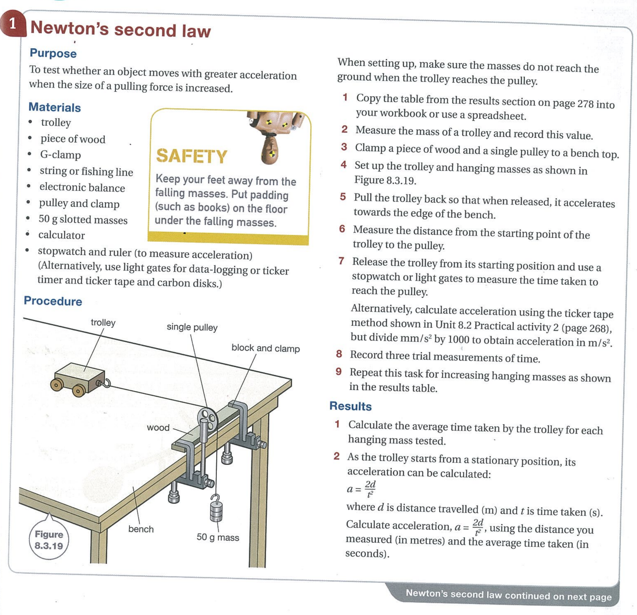

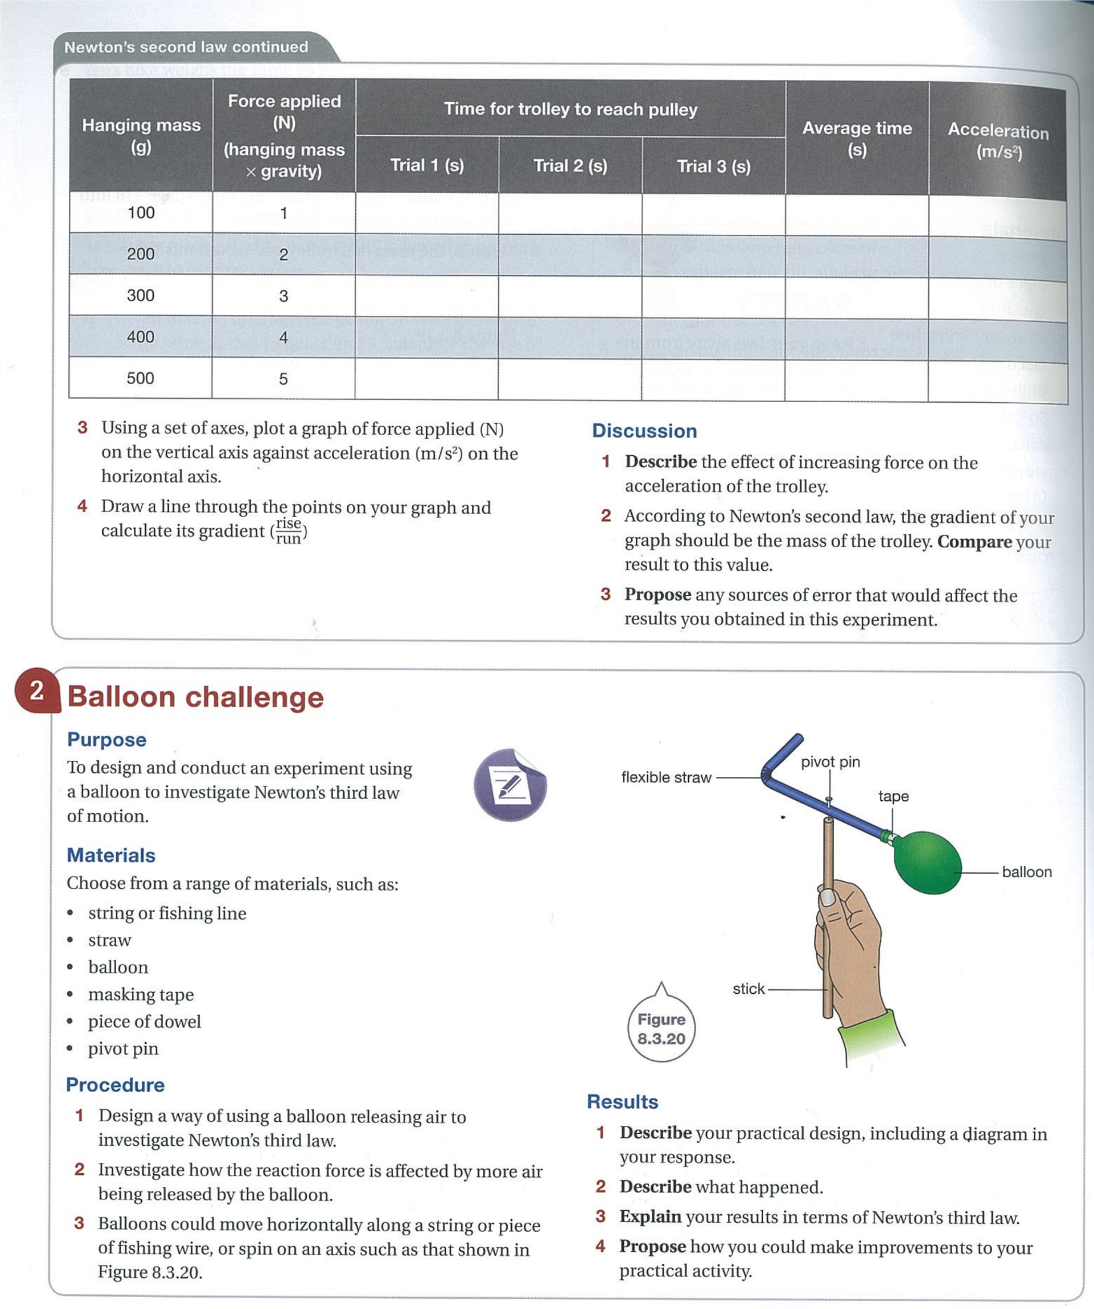

# Newton’s Third Law

**Flashcard Vocab**: action force, action-reaction pair, Newton’s third law, reaction force

## page10image37761840Demo: Water bottle rocket launches (mass dependent)

How did changing the amount of water in the bottle  
affect its flight?

\_\_\_\_\_\_\_\_\_\_\_\_\_\_\_\_\_\_\_\_\_\_\_\_\_\_\_\_\_\_\_\_\_\_\_\_\_\_\_\_\_\_\_\_\_\_\_\_

\_\_\_\_\_\_\_\_\_\_\_\_\_\_\_\_\_\_\_\_\_\_\_\_\_\_\_\_\_\_\_\_\_\_\_\_\_\_\_\_\_\_\_\_\_\_\_\_

\_\_\_\_\_\_\_\_\_\_\_\_\_\_\_\_\_\_\_\_\_\_\_\_\_\_\_\_\_\_\_\_\_\_\_\_\_\_\_\_\_\_\_\_\_\_\_\_

Why does the bottle rocket shoot upwards?

* The pressurised air and water mixture pushes against the bottle equally in every direction. When the pressure reaches a critical level, it pops the “cork” out of the nozzle and the pressurised air and water is expelled.

The upward force of thrust is great enough to overcome the downward forces of weight and air resistance.

* The forces against the sides cancel out, but there is an unbalanced force pushing upwards once the nozzle is open. This unbalanced force creates the thrust.
* Newton’s third law explains that as the air-water mixture pushes the bottle upwards, the bottle pushes the air-water mixture downwards with an equal and opposite force.

|  |  |  |
| --- | --- | --- |
| **3rd Law** | ***For every action force there is an equal and opposite reaction force, and these forces act on different objects.*** | |
| This means: **forces always act in pairs**, **in opposite directions**, and on **different objects**.  Each pair of forces is known as an **action-reaction pair**. | | |
| * As a wing pushes air down (action), the air pushes the wing and plan up (reaction), creating lift. | | * As expanding gases are pushed out of the pressure chamber (action), the gases push the vehicle forward (reaction). |
| A picture containing clock  Description automatically generated  downwash  wing pushes air down (action) air pushes wing up (reaction)  air deflected down  lift  incident airflow | |  |

* The table below gives examples of action-reaction pairs:

|  |  |
| --- | --- |
| **Action Force** | **Reaction Force** |
| A nail is hit by a hammer. | The nail exerts an equal force back on the hammer. |
| A sprinter pushes back on the starting blocks as a race begins. | The starting blocks push forward on the sprinter. |
| A book resting on a table exerts its weight force onto the table. | The table exerts an equal reaction force upwards on the book. |
| An octopus squirts water out as jets through a tube just below its head. | These water jets push back on the octopus, propelling it in the opposite direction. |
| You stand on a skateboard and push against a wall. | The wall pushes back on you with equal force, and you move away. |

### Demo: Get your skates on!

|  |  |  |
| --- | --- | --- |
| **Scenario** | **Observation** | **Explanation** |
|  |  |  |

**Think!**

1. If action-reaction forces are always equal and opposite, then how can there ever be an unbalanced force?

|  |  |
| --- | --- |
| What’s the difference? | |
|  |  |
|  |  |

1. If colliding objects exert the same force on each other, then why isn’t there equal movement?

|  |
| --- |
|  |

1. If forces during a collision are equal in size on both objects, then why isn’t there equal damage?

|  |
| --- |
|  |

### Newton’s Laws: Key Points

* Only an **unbalanced** force can cause a change of motion, i.e. acceleration – Newton’s 1st Law
* The greater the force, the greater the acceleration – Newton’s 2nd Law
* The same force will accelerate a smaller mass more than a larger mass – Newton’s 2nd Law
* Newton’s 3rd Law:
* Action-reaction forces always act on **different** **objects**; otherwise, they would cancel out and no acceleration would be possible.
* Action-reaction forces are always **equal in size**, but different effects are possible if each object has a different mass (amount of inertia), or other differences such as strength, softness etc.
* Action-reaction forces always act in **opposite directions** to each other; if one object accelerates, the other will usually decelerate.
* Forces always exist as **action-reaction pairs**, even if it’s not obvious.

**Exercises** Explain each of these scenarios in terms of Newton’s 3rd Law:

|  |  |  |  |
| --- | --- | --- | --- |
| **Scenario** | **Explanation** | **Scenario** | **Explanation** |
|  | Action force:  Reaction force:  Effect: |  | Action force:  Reaction force:  Effect: |
|  | Action force:  Reaction force:  Effect: |  | Action force:  Reaction force:  Effect: |
|  | Action force:  Reaction force:  Effect: |  | Action force:  Reaction force:  Effect: |
|  | Action force:  Reaction force:  Effect: |  | Action force:  Reaction force:  Effect: |
|  | Action force:  Reaction force:  Effect: |  | Action force:  Reaction force:  Effect: |
|  | Action force:  Reaction force:  Effect: |  | Action force:  Reaction force:  Effect: |

## Exercise Set V: Forces 2 and Physics Topic Test Revision

Collect and complete the worksheets, then mark your work using the answers provided.

|  |  |  |
| --- | --- | --- |
| Worksheet: “Forces 2” |  | |
| Worksheet: “Physics Topic Test Revision” | |  |

## **EXT: Motion Revision for Topic Test**

1. Define (and explain the difference between) distance and displacement and state whether each is a vector or scalar quantity.
2. What is meant by the terms vector and scalar quantities?
3. Find the distance and displacement of:
4. A tennis ball rolls 4 m to the left and then bounces back 6 m.
5. A man walks 3 km south and then 2km west.
6. Explain the difference between speed and velocity.
7. A runner completes 3 laps of a 200 m circular track in 104 s.
8. Calculate the average speed.
9. Calculate the average velocity
10. A wookie runs 16.5 m south in 2.0 s then 18.9 m North in 3.1 s.
    * 1. What is the distance travelled?
      2. What is the displacement?
      3. What is the average speed?
      4. What is the average velocity?
      5. If the fineness of the scale used to measure the length and time were 0.05 m and 0.02 s respectively, determine the absolute and percentage uncertainty of the lengths and times measured.
11. A soccer ball was kicked towards the goals 8 m away. If the ball reached the catcher in 1.2 s, what was the average speed of the ball?
12. A snail crawled for 15 minutes in a straight line. If the snail could maintain an average velocity of 0.01 m s-1, how far did the snail get?
13. A jet plane travels at a constant velocity of 580 m s-1 for 2 km. How long does this take?
14. Define acceleration, write the formula for calculating it and state the units it is measured in.
15. Mr Magoo’s combie van can reach a velocity of 60 kmph in 1 minute from a standing start. What is the van's acceleration?
16. How long would it take a car to change from 10 m s-1 to 20m s-1 if it could accelerate at 2.5 m s-2?
17. How far would a parachutist fall in the first 3.5 seconds? (a = 9.8 m s-2, u = 0 m s-1) EXT
18. What is deceleration?
19. What is the deceleration of a cyclist if he slows down from 8 m s-1 to rest in 10 s?
20. An object decelerates at 8 m s-2 over 5 seconds. If its initial velocity was 60 m s-2 what is its final velocity?
21. How far does an object travel if it starts at 6ms-1 and accelerates at a constant rate of

2 m s-2 for 9 seconds? EXT

1. An X-Wing fighter is travelling horizontally at 31.0 m s-1 when it engages its turbo thrusters for 3.51 s. at the end of this time, its velocity is 273 m s-1. Calculate:
2. The acceleration.
3. The distance travelled while accelerating.EXT
4. How long does it take a car to cover 90 m from the traffic lights if it accelerates at 5 m s-2?
5. Draw a ticker tape that shows:
6. constant velocity followed by rapid deceleration
7. rapid acceleration followed by slow deceleration.
8. Two timer tapes were analysed and the following information was recorded:

Tape Intervals (spaces on tape) Length

1 5 34 mm

2 12 50 mm

1. How long did the motion on each tape last for?
2. What was the average velocity recorded on each tape in m s-1?
3. What is the absolute and percentage uncertainty of each measurement?
4. Define force and state the units it is measured in.
5. Name 4 changes that can tell you that a force is acting on an object.
6. Bozo throws a baseball into the air. What is the source of the force, the object the force is acting on and the effect of the force?
7. What is the difference between mass and weight?
8. If your mass is 45 kg what is your weight on earth?
9. What is Sam’s mass if his weight is 650 N?
10. State Newton's three Laws of Motion.
11. How much force is required to accelerate a 1 tonne Rodeo at 5 m s-2?
12. What acceleration would result from pushing a 80 kg crate with a force of 900 N?
13. An object is accelerated at 2 m s-2 with a force of 300 N. What is its mass?
14. How long does it take an object with a mass of 100 kg to be moved with a force of 200 N from rest to a velocity of 5 m s-1?
15. What is the mass of an object if it moves from rest to 10 m s-1 in 5 seconds when pushed with a force of 30 N?
16. Explain why:
17. Eggs fly off the back seat when you stop suddenly
18. You fall out of your seat as a bus takes the corner.
19. You slip when you walk on a banana peel.
20. When John jumped off a boat for the jetty he fell in the water.
21. A gun experiences recoil.
22. Explain the safety features in a car, referring to Newton’s laws.

# Work and Energy

**Flashcard Vocab**: energy, energy transfer, energy transformation, impact force, work

## Demo: Work done by a falling object

What happens if different masses, dropped from the same height,

strike the Plasticine?

\_\_\_\_\_\_\_\_\_\_\_\_\_\_\_\_\_\_\_\_\_\_\_\_\_\_\_\_\_\_\_\_\_\_\_\_\_\_\_\_\_\_\_\_\_\_\_\_\_\_\_\_\_\_\_\_

\_\_\_\_\_\_\_\_\_\_\_\_\_\_\_\_\_\_\_\_\_\_\_\_\_\_\_\_\_\_\_\_\_\_\_\_\_\_\_\_\_\_\_\_\_\_\_\_\_\_\_\_\_\_\_\_

What happens if the same mass is dropped from different heights?

**Plasticine**

\_\_\_\_\_\_\_\_\_\_\_\_\_\_\_\_\_\_\_\_\_\_\_\_\_\_\_\_\_\_\_\_\_\_\_\_\_\_\_\_\_\_\_\_\_\_\_\_\_\_\_\_\_\_\_\_

\_\_\_\_\_\_\_\_\_\_\_\_\_\_\_\_\_\_\_\_\_\_\_\_\_\_\_\_\_\_\_\_\_\_\_\_\_\_\_\_\_\_\_\_\_\_\_\_\_\_\_\_\_\_\_\_\_\_\_\_\_\_\_\_\_\_\_\_\_\_\_\_\_\_\_\_\_\_\_\_\_\_\_\_\_\_\_\_\_\_\_\_\_\_\_\_\_\_\_\_\_\_\_\_\_\_\_\_\_\_\_\_\_\_\_\_\_\_\_\_\_\_

### Explanation

* We know that an unbalanced force is able to move an object, or change its shape.
  + In the demo, the falling mass impacted the Plasticine with an unbalanced force; the greater the force, the larger the dent.
* In physics, we say that **work is done** whenever a force causes movement or rearranges matter somehow. **The larger the force, the greater the work done**.
  + In the demo, using a heavier mass or dropping the mass from a greater height increased the force of impact, and therefore the amount of work done on the Plasticine.
* It takes energy to generate a force. By definition, **energy is the ability to do work**.
  + When work is done, energy is always transferred or transformed.
    - When energy is passed **from one object to another** we say it has been **transferred**.
    - When energy changes **from one form to another** we say it has been **transformed**.
  + Energy has the same units as work because the amount of work done depends on the amount of energy transferred or transformed.
  + The **standard unit** for both **work** and **energy** is the **joule** (**J**).
* Work can be calculated by multiplying the force by the distance it moves an object:

$W=Fs$ where *W* is the work done (don’t confuse with ‘weight’)

and s is the displacement through which the force acts to cause movement

## A picture containing text Description automatically generatedWorked Examples

1. How much work must be done to lift a 135 kg barbell 50 cm off the ground?

Lifting involves working against gravity. The average force required to lift a mass has to equal the force of gravity pulling down, i.e. the weight of the mass.

Weight of barbell:

$$W=mg=135×9.80=1323 \text{N}$$

Work done:

$$W=Fs=1323×0.5=661.5 \text{J}$$

m = 135 kg

g = 9.80 m/s2

d = 50 cm = 0.5 m

|  |  |
| --- | --- |
| Watch: “2011 Volvo S60 Sedan - Frontal full width crash test” (YouTube) |  |

1. The Volvo in the crash test was moving at 40 km/h. It had a mass of approximately 1 500 kg. The footage reveals that it stops in 66 ms over a distance of 0.37 m, which equals the amount the crumple zone shortened (crushed).
   1. How much work was done by the barrier to stop the car?  
      (Hint: Calculate deceleration first, then force, and use it to find work.)

[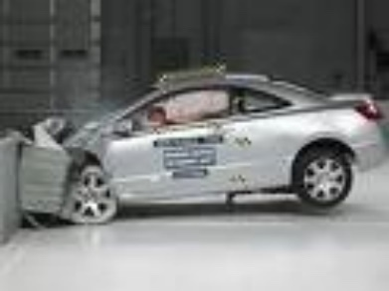](http://www.google.com.au/imgres?imgurl=http://2.bp.blogspot.com/_IUYlNU10BMY/SmmOT8MH5NI/AAAAAAAAbc0/Pg-07KyobGA/s400/car-Crash-Tests-04.jpg&imgrefurl=http://coolhqpix.blogspot.com/2009/07/car-crash-tests.html&usg=__n4cc47Z0dyjFQYvInySaufF6cjY=&h=301&w=400&sz=23&hl=en&start=156&zoom=1&um=1&itbs=1&tbnid=FpCL4zmnDtirDM:&tbnh=93&tbnw=124&prev=/search?q%3Dkinetic%2Benergy%2Band%2Bwork%2Bcar%2Bcollision%2Bwith%2Bwall%26start%3D144%26um%3D1%26hl%3Den%26sa%3DN%26biw%3D1345%26bih%3D592%26ndsp%3D18%26tbm%3Disch&ei=iDYmTpCtIMyHmQXQ7MHkCQ)

* 1. How much energy did the crumple zone absorb? \_\_\_\_\_\_\_\_\_\_ J

1. (i) If a raw egg of mass 50 g is dropped onto a bench from a height of 60 cm, how must work must the bench do on the egg (which crushes) to stop it? (ii) Estimate the force of impact if the egg crushes to a depth of 2 cm (Hint: Use F = W/d).

## **Energy and Work Calculations:**

The work done on an object is equal to the change in energy.

$$Work= ∆ Energy=change in Energy$$

**Examples:**

1. **A change in kinetic energy:**

Find the work done by the brakes of a bicycle to reduce its speed from 10ms-1 to 4ms-1, if the combined mass of the bicycle and cyclist is 85kg.

2. **Change in Gravitational Potential Energy**

Determine the work required to lift a 40kg bag of fertiliser onto a shelf, which is 1.2m above the ground.

**Questions:**

1. How much work is required to lift a bag of wheat that is 50 kg to a height of 1.8 m?
2. If an 8 kg object gains 4000 J of gravitational potential energy when it is carried up a tower, how high is the tower? How much work was done in carrying the object up the tower?
3. A 3 kg rock rolls down a hill at 3 m s-1. How much work must be done in stopping the rock?
4. How much work must be done to stop a 1200 kg car travelling at 10 m s-1

1. 882 J 2. 51.0 m 3. 13.5 J 4. 60000 J

## **Work** - EXTENSION



WORK is done when a **force** acts to **move** an object in the direction of the force.

So, for work to done:

1. A force must be applied to an object in the direction of the displacement.
2. The object must move.

* measured in joules (J) (clipart)
* **W = F x s (**work = force x displacement) Force in N; displacement in m

If James pushes on a wall, he is **not** doing work on the wall, because the wall does not move.

When you **lift an object up**, you do work against gravity. The work done to lift an object can be calculated using, W = F x s, where F = weight of object and s = height lifted.

**Calculations**

1. Find the work done when a box is pushed a distance of 18m over a rough surface of frictional resistance 30N.
2. How much work has been done in stopping a car if the brakes offer a resistance of 1000N and the distance covered in bringing the car to rest is 55m?
3. Calculate the distance covered by an object if an applied force of 50N does 250J of work.
4. What force is required to push a car over a distance of 15m if the work done is 60 000J?
5. An oil drum is rolled along a smooth surface for a distance of 25m with a force of 18N. How much work has been done?
6. A car is accelerated at 5 m s-2 for a distance of 20m. If the mass of the car is 1500kg, how much work has been performed?
7. If an object requires 200J of work to be accelerated at 1.5 m s-2 for a distance of 40m, determine the mass of the object.
8. How much work has been done if a car of mass 2000kg is decelerated at 1.5 m s-2 for a distance of 80m?
9. A skater, initially at rest, does 250J of work to accelerate at 1m/s2. If his mass is 70kg, how far has he travelled during his acceleration?
10. A box of mass 12kg requires a force of 4N to overcome friction so that it can be moved at a constant velocity over a distance of 1.5m
    1. How much work is required?
    2. What additional work would have been required if the box had been accelerated at

0.2 m s-2 for the 1.5m shift?

1. A forklift raises crates of mass 600kg a height of 3m. How much work is done?
2. What is the mass of a lift if 400 000J is required to raise the lift a height of 20m?
3. How much work is done by three people as they try push a bogged car out of the mud but the car does not move. Each person applies a force of 500N.

**Answers**

**1.** 540J **2**. 55000 **3**. 5m **4**. 4000N **5**. 450J **6**. 150 000J **7**. 3.3kg **8**. 240000J

**9.** 3.6m **10**. a) 6J b) 3.6J **11**. 17640J **12**. 2040.8kg **13**. 0J

### Energy unit conversions

1. Convert the following:
   * 4.2 kJ = \_\_\_\_\_\_\_\_ J 0.809 MJ = \_\_\_\_\_\_\_\_\_ J
   * 6 880 J = \_\_\_\_\_\_\_\_ kJ 1 400 000 J = \_\_\_\_\_\_\_ MJ
   * 0.056 kJ = \_\_\_\_\_\_\_\_\_\_ J 2.2 MJ = \_\_\_\_\_\_\_\_\_ kJ
   * 5.5 kJ = \_\_\_\_\_\_\_\_\_\_\_ J 0.64 MJ = \_\_\_\_\_\_\_\_\_\_\_\_\_\_ J
   * 3 500 J = \_\_\_\_\_\_\_\_\_\_ kJ 850 000 000 J = \_\_\_\_\_\_\_\_\_\_\_ MJ
2. How much work is done by gravity on a 0.5 kg mass that falls from a height of 0.75 m?
3. A 250 g mass strikes a layer of Plasticine and creates a dent of depth 0.5 cm.
4. How much work is done by a layer of playdough to completely stop a falling bocce ball that strikes it with a force of 450 N to create a divot of depth 0.6 cm?

## **Energy**

*Energy is the capacity to do work.*

## **Energy Transformations**

Energy comes in different forms and can be classified in 2 categories:

|  |  |
| --- | --- |
| **Types of Energy** | |
| **Active (Moving)** | **Potential Energy (Stored)** |
| Kinetic | Gravitational |
| Heat | Chemical |
| Sound | Nuclear |
| Radiant (EMR - light) | Elastic |
| Electric | Electrostatic |

**For each of the following objects identify the energy transformation that is taking place:**

1. A toaster. \_\_\_\_\_\_\_\_\_\_\_\_\_\_\_\_\_\_\_\_\_\_\_\_\_\_\_\_\_\_\_\_\_\_\_\_\_\_\_\_\_\_\_\_\_\_\_\_\_\_\_\_\_\_\_\_\_\_\_\_\_\_\_\_\_\_\_\_\_\_\_\_\_\_

2. A blender. \_\_\_\_\_\_\_\_\_\_\_\_\_\_\_\_\_\_\_\_\_\_\_\_\_\_\_\_\_\_\_\_\_\_\_\_\_\_\_\_\_\_\_\_\_\_\_\_\_\_\_\_\_\_\_\_\_\_\_\_\_\_\_\_\_\_\_\_\_\_\_\_\_\_

1. The Sun. \_\_\_\_\_\_\_\_\_\_\_\_\_\_\_\_\_\_\_\_\_\_\_\_\_\_\_\_\_\_\_\_\_\_\_\_\_\_\_\_\_\_\_\_\_\_\_\_\_\_\_\_\_\_\_\_\_\_\_\_\_\_\_\_\_\_\_\_\_\_\_\_\_\_

4. Cellular respiration. \_\_\_\_\_\_\_\_\_\_\_\_\_\_\_\_\_\_\_\_\_\_\_\_\_\_\_\_\_\_\_\_\_\_\_\_\_\_\_\_\_\_\_\_\_\_\_\_\_\_\_\_\_\_\_\_\_\_\_\_\_\_\_\_\_\_\_

5. A natural gas stove. \_\_\_\_\_\_\_\_\_\_\_\_\_\_\_\_\_\_\_\_\_\_\_\_\_\_\_\_\_\_\_\_\_\_\_\_\_\_\_\_\_\_\_\_\_\_\_\_\_\_\_\_\_\_\_\_\_\_\_\_\_\_\_\_\_\_\_

6. A battery.\_\_\_\_\_\_\_\_\_\_\_\_\_\_\_\_\_\_\_\_\_\_\_\_\_\_\_\_\_\_\_\_\_\_\_\_\_\_\_\_\_\_\_\_\_\_\_\_\_\_\_\_\_\_\_\_\_\_\_\_\_\_\_\_\_\_\_\_\_\_\_\_\_\_\_

7. A phone charger. \_\_\_\_\_\_\_\_\_\_\_\_\_\_\_\_\_\_\_\_\_\_\_\_\_\_\_\_\_\_\_\_\_\_\_\_\_\_\_\_\_\_\_\_\_\_\_\_\_\_\_\_\_\_\_\_\_\_\_\_\_\_\_\_\_\_\_\_\_

8. Solar panels. \_\_\_\_\_\_\_\_\_\_\_\_\_\_\_\_\_\_\_\_\_\_\_\_\_\_\_\_\_\_\_\_\_\_\_\_\_\_\_\_\_\_\_\_\_\_\_\_\_\_\_\_\_\_\_\_\_\_\_\_\_\_\_\_\_\_\_\_\_\_\_\_

9. A nuclear bomb. \_\_\_\_\_\_\_\_\_\_\_\_\_\_\_\_\_\_\_\_\_\_\_\_\_\_\_\_\_\_\_\_\_\_\_\_\_\_\_\_\_\_\_\_\_\_\_\_\_\_\_\_\_\_\_\_\_\_\_\_\_\_\_\_\_\_\_\_\_\_

10. A plant photosynthesising. \_\_\_\_\_\_\_\_\_\_\_\_\_\_\_\_\_\_\_\_\_\_\_\_\_\_\_\_\_\_\_\_\_\_\_\_\_\_\_\_\_\_\_\_\_\_\_\_\_\_\_\_\_\_\_\_\_\_\_\_\_\_

11. A wind farm. \_\_\_\_\_\_\_\_\_\_\_\_\_\_\_\_\_\_\_\_\_\_\_\_\_\_\_\_\_\_\_\_\_\_\_\_\_\_\_\_\_\_\_\_\_\_\_\_\_\_\_\_\_\_\_\_\_\_\_\_\_\_\_\_\_\_\_\_\_\_\_\_

12. A light bulb. \_\_\_\_\_\_\_\_\_\_\_\_\_\_\_\_\_\_\_\_\_\_\_\_\_\_\_\_\_\_\_\_\_\_\_\_\_\_\_\_\_\_\_\_\_\_\_\_\_\_\_\_\_\_\_\_\_\_\_\_\_\_\_\_\_\_\_\_\_\_\_\_\_

13. A violin. \_\_\_\_\_\_\_\_\_\_\_\_\_\_\_\_\_\_\_\_\_\_\_\_\_\_\_\_\_\_\_\_\_\_\_\_\_\_\_\_\_\_\_\_\_\_\_\_\_\_\_\_\_\_\_\_\_\_\_\_\_\_\_\_\_\_\_\_\_\_\_\_\_\_\_\_

14. A stretched rubber band being flicked across the room. \_\_\_\_\_\_\_\_\_\_\_\_\_\_\_\_\_\_\_\_\_\_\_\_\_\_\_\_\_\_\_\_\_\_\_\_\_\_\_\_

# Kinetic Energy

**Flashcard Vocab**: kinetic energy

## Graphical user interface, application Description automatically generatedDemo: Energy transfer (P10.p280)

Why is the velocity of the smaller ball so much greater than  
the larger one?

\_\_\_\_\_\_\_\_\_\_\_\_\_\_\_\_\_\_\_\_\_\_\_\_\_\_\_\_\_\_\_\_\_\_\_\_\_\_\_\_\_\_\_\_\_\_\_\_\_

\_\_\_\_\_\_\_\_\_\_\_\_\_\_\_\_\_\_\_\_\_\_\_\_\_\_\_\_\_\_\_\_\_\_\_\_\_\_\_\_\_\_\_\_\_\_\_\_\_

\_\_\_\_\_\_\_\_\_\_\_\_\_\_\_\_\_\_\_\_\_\_\_\_\_\_\_\_\_\_\_\_\_\_\_\_\_\_\_\_\_\_\_\_\_\_\_\_\_

\_\_\_\_\_\_\_\_\_\_\_\_\_\_\_\_\_\_\_\_\_\_\_\_\_\_\_\_\_\_\_\_\_\_\_\_\_\_\_\_\_\_\_\_\_\_\_\_\_

* **Kinetic energy** is **energy of motion**. Any moving object has kinetic energy.
* The kinetic energy of an object in simple straight-line motion can be found using:

|  |  |  |  |
| --- | --- | --- | --- |
| $$\text{KE}=\frac{1}{2}mv^{2}$$ | where | KE= $$m=$$ $$v=$$ | kinetic energy, measured in joules (J)  mass, measured in kilograms (kg)  velocity, measured in metres per second (m/s or ms-1) |

Note: All non-standard units must be first converted to the standard units shown above.

### **Worked Example**

A CO2 dragster can achieve an experimental top speed of 24.5 m/s. How much kinetic energy does it possess at that speed if its mass is 75 g?

|  |
| --- |
| *m* = $75÷1000$ = 0.075 kg |
| $$\text{KE}=\frac{1}{2}mv^{2}=0.5×0.075×{24.5}^{2}=2.3 \text{J}$$ |

### Practice Examples

1. Calculate the KE of a 1.4 kg bowling ball travelling in a straight line at a speed of 6 m/s.
2. A space capsule strikes the sea with a velocity of 20 m/s. If it has a mass of 1 500 kg, what is its KE on impact with the sea?
3. A ping pong ball is hit and strikes a student on the back with a velocity of 15 m/s. If the ball has a mass of 2.7 g, with what KE does the ball strike the student?  
   (Hint: Convert grams to kilograms!)

**EXT**: **Calculations**

1. Calculate the kinetic energy of a 50 kg person running with a velocity of 5 m s-1.
2. What is the kinetic energy of a bullet of mass 2 g travelling at a velocity of 750 m s-1?
3. Which car has greater kinetic energy?

A 1000 kg car travelling at 18 m s-1  or a 2000 kg car travelling at 9 m s-1?

1. What is the mass of an object with 200 J of kinetic energy if it is travelling at 5 m s-1?
2. Find the velocity of a 5000 kg plane flying with 250000 J of kinetic energy.

**Answers**

1. 625 J 2. 562.5 J 3. The 1000 kg car 4. 16 kg 5. 10 ms-1

# Potential Energy

**Flashcard Vocab**: elastic potential energy, gravitational potential energy, potential energy

## Activity: How much can you lift?

Visit **https://strengthlevel.com/strength-standards** Set it for your gender, and use kg. Choose an exercise and estimate how much you could lift by reading the table.

Lifting weights takes energy because we are working against the force of gravity. The heavier the object, the greater the amount of energy required to raise it.

Name of my chosen exercise: \_\_\_\_\_\_\_\_\_\_\_\_\_\_\_\_\_\_\_\_

Estimated lift I could perform: \_\_\_\_\_\_\_\_\_\_ kg

My rating for this lift (novice etc.): \_\_\_\_\_\_\_\_\_\_\_\_\_\_\_\_\_\_\_\_

* **Potential energy** (PE) is **stored energy** which can be used to do

work. Two common forms are:

* + A picture containing text

    Description automatically generated**Elastic** PE – the energy stored within a stretched, compressed or twisted object, such as a spring or rubber band; and
  + **Gravitational PE** – the energy of an object raised above the Earth's surface.

### Example

* **Stretching a band**: the **work** done on it  
   **gives it elastic PE**.
* **Raising a mass**: the **work** done on it,  
   **gives it gravitational PE**.
  + In both cases, this stored energy is  
    **converted** back **into KE** when released.

### Example

* Going up and down hills converts energy between gravitational PE and KE.

Rider has maximum PE \_\_\_\_\_\_\_\_\_\_\_\_\_\_\_\_\_\_\_  
\_\_\_\_\_\_\_\_\_\_\_\_\_\_\_\_\_\_\_.

Going uphill the rider \_\_\_\_\_\_\_\_\_\_\_\_\_\_\_\_\_  
\_\_\_\_\_\_\_\_\_\_\_\_\_\_\_\_\_.

Rider cycles downhill and loses \_\_\_\_\_\_\_\_\_\_\_\_\_\_\_   
\_\_\_\_\_\_\_\_\_\_\_\_\_\_\_\_\_\_\_\_.

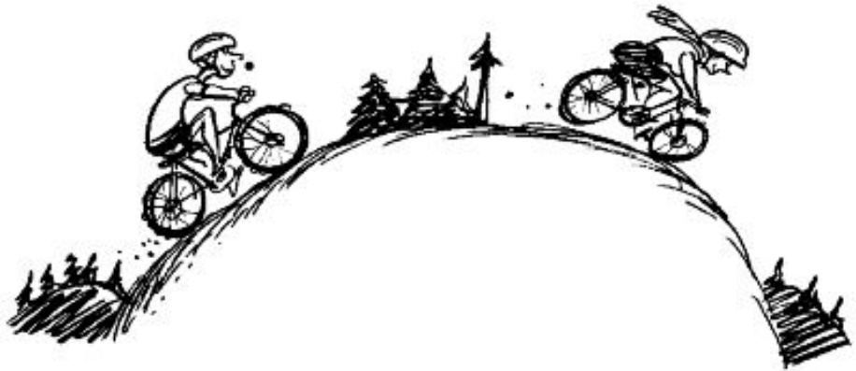

Rider’s PE at ground level is \_\_\_\_\_\_\_\_\_\_.

(Greg’s cycling blog)

* To calculate gravitational potential energy:

|  |  |  |  |
| --- | --- | --- | --- |
| $$PE=mgh$$ | where | $$\text{PE}=$$ $$m=$$ $$g=$$ $$h=$$ | potential energy, measured in joules (J)  mass, measured in kilograms (kg)   * 1. /s2 on Earth   height above the ground (m)  REFERENCE where h = 0 |

Note: All non-standard units must be first converted to the standard units shown above.

* The amount of PE depends on height above ground and mass:
  + An object raised **higher** stores **more gravitational PE**.
  + Diagram

    Description automatically generatedAn object with **greater mass** stores **more gravitational PE**.

Example:

**A B C**

* + Ball B has twice as much PE as ball A because it is \_\_\_\_\_\_\_\_\_\_ as high.
  + Ball C has twice as much PE as ball A because it has twice the \_\_\_\_\_\_\_\_.
  + So balls B and C have the \_\_\_\_\_\_\_\_ amount of GPE as each other.

## Worked Example

1. How much gravitational potential energy (PE) does a 135 kg barbell gain when it is lifted 50 cm off the ground? How does this compare to the amount of work done in lifting it?

## Practice Examples

1. A rocket of mass 25 kg reaches a height of 500 m before beginning its fall back to earth. What is its maximum potential energy (PE)?
2. An athlete of mass 60 kg jumps vertically upward such that her centre of gravity is lifted to a position 56 cm above the ground. What is her PE at her highest point above the ground?
3. A hoist is a car service centre lifts a one tonne car to a height of 1.2 m above the ground. How much energy was expended by the hoist? [Note: 1 t = 1 tonne = 1 000 kg]

**EXT: Calculations**

1. If a crate of mass 9 kg is lifted 1.5 m above the ground onto the back of a truck, calculate the increase in gravitational potential energy of the crate.
2. Determine the height a 150 kg beam is lifted by a crane when it gains 4.56 x 103 J of gravitational potential energy.
3. A rocket of mass 25 kg reaches a height of 500 m above the ground before it falls back to Earth. What is its maximum potential energy?
4. A drum of mass 80 kg is rolled up a ramp to a height of 2.3 m above the ground. What is its gain in gravitational potential energy?
5. A tile of mass 2 kg drops off a roof and loses 290 J of gravitational potential energy in falling back to the ground. Determine the height of the roof.

Answers:

1. 132 J 2. 3.10 m 3. 1.23 x 105 J 4. 1.80 x 103 J 5. 1.48 m

## Exercise Set VI: Energy

Collect the review worksheet, complete it, and mark your work using the answers provided.

|  |  |
| --- | --- |
| Worksheet: “Energy” |  |

# Conservation of Energy

**Flashcard Vocab**: bob, Law of Conservation of Energy, pendulum, surroundings, system

## Demo: Big pendulum

Explain why it is safe to let a massive pendulum go from just in front of the face and allow it to swing back towards you.

\_\_\_\_\_\_\_\_\_\_\_\_\_\_\_\_\_\_\_\_\_\_\_\_\_\_\_\_\_\_\_\_\_\_\_\_\_\_\_\_\_\_\_\_\_\_\_\_\_\_\_\_\_\_\_\_\_\_\_\_\_\_\_\_\_\_\_\_\_\_\_\_\_\_\_\_

\_\_\_\_\_\_\_\_\_\_\_\_\_\_\_\_\_\_\_\_\_\_\_\_\_\_\_\_\_\_\_\_\_\_\_\_\_\_\_\_\_\_\_\_\_\_\_\_\_\_\_\_\_\_\_\_\_\_\_\_\_\_\_\_\_\_\_\_\_\_\_\_\_\_\_\_

* The **Law of Conservation of Energy** states that **energy cannot be created or destroyed**.
  + This means that during energy transformations, the **total energy remains constant**.
  + Energy lost from the **system** is actually just being transferred to the **surroundings** in wasted forms such as heat, sound etc.
* If no energy is ever lost, a pendulum would keep swinging forever! Energy is simply being converted back and forth between gravitational PE and KE.

### Exercise: Energy changes in a pendulum

Many types of motion are like a pendulum swing. The diagram shows the energy changes.

1. How do we know that kinetic energy at the top of the swing is zero?

\_\_\_\_\_\_\_\_\_\_\_\_\_\_\_\_\_\_\_\_\_\_\_\_\_\_\_\_\_\_\_\_\_\_\_\_\_\_\_\_\_\_\_\_\_\_\_\_\_\_\_\_\_\_\_\_\_\_\_\_\_\_\_\_\_\_\_\_\_\_\_\_\_

1. What energy transformation takes place (i) on the way down? (ii) on the way up?

\_\_\_\_\_\_\_\_\_\_\_\_\_\_\_\_\_\_\_\_\_\_\_\_\_\_\_\_\_\_\_\_\_\_\_\_\_\_\_\_\_\_\_\_\_\_\_\_\_\_\_\_\_\_\_\_\_\_\_\_\_\_\_\_\_\_\_\_\_\_\_\_\_

1. Suppose the maximum PE of a pendulum **bob** (the mass) is 2 joules. Assuming no energy is lost to the surroundings, how much KE will the bob have at the bottom of its swing?

\_\_\_\_\_\_\_\_\_\_\_\_\_\_\_\_\_\_\_\_\_\_\_\_\_\_\_\_\_\_\_\_\_\_\_\_\_\_\_\_\_\_\_\_\_\_\_\_\_\_\_\_\_\_\_\_\_\_\_\_\_\_\_\_\_\_\_\_\_\_\_\_\_

## Interactive: Energy Skate Park Basics (PhET)

Visit **https://phet.colorado.edu/sims/html/energy-skate-park-basics/latest/energy-skate-park-basics\_en.html** and explore energy conservation in a skate park.

Test the effect of changing masses, heights, and adding friction. Write a summary below.

\_\_\_\_\_\_\_\_\_\_\_\_\_\_\_\_\_\_\_\_\_\_\_\_\_\_\_\_\_\_\_\_\_\_\_\_\_\_\_\_\_\_\_\_\_\_\_\_\_\_\_\_\_\_\_\_\_\_\_\_\_\_\_\_\_\_\_\_\_\_\_\_\_\_\_\_

\_\_\_\_\_\_\_\_\_\_\_\_\_\_\_\_\_\_\_\_\_\_\_\_\_\_\_\_\_\_\_\_\_\_\_\_\_\_\_\_\_\_\_\_\_\_\_\_\_\_\_\_\_\_\_\_\_\_\_\_\_\_\_\_\_\_\_\_\_\_\_\_\_\_\_\_

\_\_\_\_\_\_\_\_\_\_\_\_\_\_\_\_\_\_\_\_\_\_\_\_\_\_\_\_\_\_\_\_\_\_\_\_\_\_\_\_\_\_\_\_\_\_\_\_\_\_\_\_\_\_\_\_\_\_\_\_\_\_\_\_\_\_\_\_\_\_\_\_\_\_\_\_

\_\_\_\_\_\_\_\_\_\_\_\_\_\_\_\_\_\_\_\_\_\_\_\_\_\_\_\_\_\_\_\_\_\_\_\_\_\_\_\_\_\_\_\_\_\_\_\_\_\_\_\_\_\_\_\_\_\_\_\_\_\_\_\_\_\_\_\_\_\_\_\_\_\_\_\_

**Calculations using conservation of energy** (assume no loss to surroundings)

When an object falls freely it loses **gravitational potential energy** as the distance above the ground **decreases**. This energy is converted into **kinetic energy** as the speed **increases.**

This means that a diver at the top of a diving tower has **maximum** potential energy and **zero** kinetic energy. When the diver dives off the tower she will have **maximum** kinetic energy just as she hits the water and **zero** potential energy. All the potential energy has been converted into kinetic energy if we assume air resistance is negligible.

In the same way, a tennis ball that is thrown straight up has maximum **kinetic** energy as it leaves the hand because it is here that it has its maximum **speed**. The ball then has its maximum **potential** energy at the top of its flight were its velocity is equal to **zero**. At this point the kinetic energy of the ball is equal to **zero**.

The amount of kinetic and potential energy of a falling body at various stages throughout the fall can be calculated.

Example: A diver has a mass of 52 kg. The diving tower she is using has a height of 6 m above the surface of the pool. Calculate the following:

1. The gravitational potential energy of the diver as she stands on the diving tower.
2. The gain in kinetic energy just as she enters the water at the completion of her dive.
3. The diver’s speed on entry into the water.

**Conservation of energy and work done**

1. State the law of conservation of energy.
2. If the bob on a pendulum has a mass of 50g and is pulled to the side to a height of 10 cm and then let go, determine the velocity of the bob at the bottom of its swing.
3. A roller coaster mass 500 kg is stationary at the top of the ride. The brake is released and the coaster plummets down to the bottom where its speed is 45 km/h. Determine the height the coaster started at.
4. A bullet traveling at 250 km/h passes through a window after which its speed slows to 200 km/h. If the mass of a bullet is 5 g determine the work that was done on the window.
5. A 58 kg diver jumps off the diving board to reach a point 15.0 m above the water before she plummets towards the pool. What is her speed as she enters the pool?
6. A bike rider expends 5 000 J of work to cycle up a hill. How high did he go if him and his bike have a mass of 56 kg.
7. How high does a ball of mass 0.5 kg reach if it is thrown upward with an initial kinetic energy of 45 J?
8. Find the mass of a stone which is dropped down a 50 m vertical shaft and strikes the bottom with 200 J of kinetic energy.

**Answers**

1. Energy cannot be created or destroyed, only transformed from one type to another. Eg electrical, light 2. 1.4 m s-1 3. 7.97 m 4. 4.34 J 5. 17.1 m s-1  6. 9.11 m 7. 9.18 m 8. 0.41 kg

|  |  |
| --- | --- |
| Lab: Energy changes in a roller coaster (cf. P10.p286) |  |
| Follow your teacher’s instructions and the steps on the lab sheet. |

# Energy loss and efficiency

**Flashcard Vocab**: efficiency, energy converter, energy efficient, inefficient, useful energy output

* **Energy converters** are never 100% efficient because some energy is always wasted, usually as heat.
* An **energy efficient** device, or machine, has a high proportion of **useful energy output**. If a lot of the **total energy input** is wasted, then the device is said to be **inefficient**.
* Reducing **friction** increases energy efficiency by preventing energy being lost as heat, sound, an unwanted vibrations that cause wear.
  + E.g. A more energy efficient car body will:
    - minimise aerodynamic drag; and
    - minimise friction in the motion of the wheels, bearings and axles.
* Efficiency is usually calculated to be the percentage of useful energy transformed using the formula:

$$\text{\%Efficiency= }\frac{\text{useful energy output}}{\text{total energy input}}×100$$

Note that the bigger number will always be on the bottom!

## Worked Example

Calculate the efficiency of a petrol engine that transforms 1000 J of chemical potential energy into 300 J of kinetic energy, and 700 J into wasted heat and sound energy.

## Practice Example

Calculate the efficiency of an electric motor that transforms 1000 J of chemical potential energy into 975 J of kinetic energy, and 25 J of wasted heat and sound energy.

## Activity: Efficiency of bouncing balls

Explain the energy changes that occur as a ball bounces but is unable to return to its original height.

## Worked Example

Determine the efficiency of a tennis ball that was dropped 5 times from a height of 200 cm.

1. Calculate the efficiency of the following: ​
   1. A petrol engine that transforms 1000 J of chemical potential energy into ​300 J of kinetic energy, and 700 J into wasted heat and sound energy.
   2. ​​​​A solar cell that transforms 300 J of light energy into 45 J of electrical ​energy and 255 J of wasted energy.
   3. ​​A wind turbine that transforms 500 J of kinetic energy in the wind to 150 ​J of electrical energy and 350 J of wasted heat and sound energy.
2. ​​Calculate how much energy is transferred as useful energy in the following: ​
   1. A 98% efficient kettle that has a total input power of 2000 J.
   2. ​​A plant that transforms 0.5% of the 200 J of light energy transferred ​from the Sun.
3. ​What would the total input energy have to be for the following: ​
   1. A light bulb that is 50% efficient and transfers 40 J of light.
   2. ​​A light bulb that is 90% efficient and transfers 40 J of light.
4. A cow has eaten 1500 kJ of stored chemical energy in the form of food. 945 kJ ​is excreted as waste products. 495 kJ is ‘used’ for respiration. ​
   1. ​How much of the original 1500 kJ is stored as chemical energy in the ​tissues of the cow?
   2. ​​The answer to part a is all the energy that can be transferred to a human. ​Calculate the efficiency of the energy transfer to the human. (Hint: how ​much of the original 1500 kJ is transferred to the human?).
5. ​ ​Could you ever have a device that provides an efficiency of over 100%?

\_\_\_\_\_\_\_\_\_\_\_\_\_\_\_\_\_\_\_\_\_\_\_\_\_\_\_\_\_\_\_\_\_\_\_\_\_\_\_\_\_\_\_\_\_\_\_\_\_\_\_\_\_\_\_\_\_\_\_\_\_\_\_\_\_\_\_\_\_\_\_\_\_\_\_

## Challenge!

If the pendulum has an efficiency of 95% on each swing, to what height will the bob rise after a single swing if it was being released from a height of 0.80 m as shown?

## L:\1. Publishing and Editorial\1. Product\Oxford Science\Oxford Science 10\3. Extras\6. Student worksheets\Artwork\4. Final jpgs\SW0742_01095.jpg

## Exercise Set VII: Energy Conservation and Efficiency and Physics Practical Test Revision

Collect and complete the worksheets, then mark your work using the answers provided.

|  |  |
| --- | --- |
| Worksheet: “Energy Conservation and Efficiency” |  |
| Worksheet: “Physics Practical Test Revision” |  |

## **Revision for Practical Test**

1. Explain work. Give appropriate examples and formulae.

2. How much work is done when a 300 g pencil case is lifted to a desk 1.3 m high?

3. How high has a boy lifted a 16 kg block if he does 16 kJ of work?

4. Explain kinetic energy. Give appropriate examples and formulae.

5. What is the kinetic energy of a bullet of mass 0.5 g moving at 320 m s-1?

6. How much work is done when a 0.5 kg ball is thrown at 7 m s-1?

7. What speed is a bullet (mass 15 g) travelling at if it has 25 J of kinetic energy?(ext/adv)

8. Explain potential energy. Give appropriate examples and formulae.

9. a) What is the potential energy possessed by a 50 kg person standing on a 3.2 m diving platform?

b) What kinetic energy is gained by the person if they jump off the balcony into a swimming pool at ground level below?

c) How fast will the person be traveling as they hit the water?

d) How much work does the water do to stop the person?

e) If the person then climbs back up to the top of the diving platform in 1.5 minutes, what power is produced by the person?

10. Explain power. Give appropriate examples and formulae.